**SEBI**

**BULLETIN**

**September 2016 VOL. 14 NUMBER 9**

**(LOGO)**

**SECURITIES AND EXCHANGE BOARD OF INDIA**

**EDITORIAL COMMITTEE**

**Mr. Ananta Barua**

**Mr. J. Ranganayakulu**

**Mr. S. V. Murali Dhar Rao**

The Securities and Exchange Board of India Bulletin is issued by the Department of Economic and Policy Analysis, Securities and Exchange Board of India under the direction of an Editorial Committee. SEBI is not responsible for accuracy of data/information/interpretations and opinions expressed in the case of signed articles/speeches as authors are responsible for their personal views. SEBI has no objection to the material published herein being reproduced, provided an acknowledgement of the same is made. The soft copy of SEBI Bulletin is available free of cost to the subscribers/readers, who register at [bulletin@sebi.gov.in](mailto:bulletin@sebi.gov.in) along with their complete address. A readable version of SEBI Bulletin is available at <http://www.sebi.gov.in>. Any comments and suggestions on any of the features/sections may be sent to [bulletin@sebi.gov.in](mailto:bulletin@sebi.gov.in)

**CONTENTS**

**CAPITAL MARKET REVIEW**

**GLOBAL MARKET REVIEW - SEPTEMBER 2016**

**HIGHLIGHTS OF DEVELOPMENTS IN INTERNATIONAL SECURITIES MARKET**

**ANNEX**

**PUBLICATIONS**

**CAPITAL MARKET REVIEW**

1. **Trends in Primary Market**
2. **Public and Rights Issues**

The primary securities market continues to show an upward trend in capital mobilisation. During August 2016, the primary market saw 10 issues that mobilised `16,636 crore compared to `2,159 crore mobilised through four issues in July 2016 (revised figures). There were nine public issues and a rights issues during the month. Among the public issues, there were seven IPOs that garnered `2,136 crore in all.

**Exhibit 1: Primary Market Trends (Public & Rights Issues)**



***Notes:***

***1. IPOs - Initial Public Offers, FPOs - Follow on Public Offers***

***2. Amount raised through debt issues for the last two months are provisional.***

***3. $ denotes as at the end of August of the respective years.***

***Source: SEBI***

1. **Private Placement**
2. **QIPs Listed at BSE and NSE**

Qualified Institutional Placement (QIP) is an alternative mode of resource raising available for listed companies to raise funds from domestic market. In a QIP, a listed issuer issues equity shares or non-convertible debt instruments along with warrants and convertible securities other than warrants to Qualified Institutional Buyers only. In August 2016, there were two QIP issues which raised `230 crore, compared to one issue in the previous month which raised `56 crore. **(*Table 10*)**

1. **Preferential Allotments Listed at BSE and NSE**

Preferential allotment also serves as an alternative mechanism of resource mobilization wherein a listed issuer issues shares or convertible securities to a select group of persons. There were 17 preferential allotments (amounting to `350 crore) listed at BSE and NSE during August 2016, compared to 27 preferential allotments (`1,470 crore) listed during July 2016. **(*Table 11*)**.

1. **Private Placement of Corporate Debt**

Private placement mechanism dominates the resource mobilization through corporate bonds. In August 2016, `71,165 crore was raised through private placement route in the corporate bond market and `14,000 crore amount was raised through public issue route. **(*Table 12 and Exhibit 1A*)**.

Further, in August 2016, the total amount mobilised through public issues and private placement of both debt and equity combined stood at `88,381 crore as compared to `40,458 crore in July 2016.

**Exhibit 1A: Total Resources Mobilised by Corporate Sector (**` **crore)**



***Notes:***

***1. Private placement of Equity includes, amount raised through preferential allotments, QIP and IPP mechanism,***

***2. Public Equity Issues includes IPO, FPO & Rights issues of common equity shares.***

***3. $ indicates as on the last day of August 2016.***

***Source: SEBI***

1. **Resource Mobilisation by Mutual Funds**

In August 2016, there were net inflows to mutual funds amounting to `25,333 crore. While net inflows to private sector mutual funds were `28,163 crore, public sector mutual funds witnessed net outflows of `2,831 crore. In August 2016, income/debt oriented schemes witnessed net inflows of `15,306 crore, while growth/equity funds and balanced schemes received net inflows of `6,505 crore and `2,733 crore respectively. Further, the FoF (Fund of fund) schemes investing overseas and GETFs (Gold Exchange Traded Funds) registered net outflows during August 2016. The cumulative net assets under management by all mutual funds increased by 2.97 per cent to `15,63,177 crore as on August 31, 2016 from 15,18,097 crore as on July 31, 2016 **(*Tables 52 & 54*)**.

1. **Trends in the Secondary Market**

The Indian stock market continued to rally in August 2016. During the month, the benchmark indices, S&P BSE Sensex and Nifty 50 rose by 1.4 percent and 1.7 percent respectively to close at 28,452.2 and 8,786.2 respectively on August 31, 2016 (***Figure 1***). Sensex and Nifty touched their intraday highs of 28,532.3 and 8,819.2 respectively on August 31, 2016. Both Sensex and Nifty touched their intraday lows of 27,628.0 and 8,544.9 on August 04, 2016 and August 03, 2016 respectively.

**Figure 1: Movement of Sensex and Nifty**

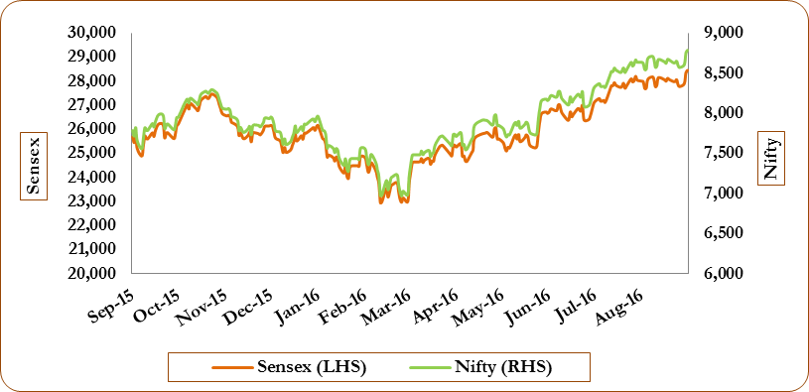

Reflecting the upward trend in market movements, the market capitalisation of BSE and NSE rose by 2.2 percent and 2.2 percent to `1,10,99,423 crore and `1,09,10,696 crore respectively, at the end of August 2016 from `1,08,63,581 crore and `1,06,75,211 crore respectively, recorded at the end of July 2016. The P/E ratios of S&P BSE Sensex and Nifty 50 were 20.8 and 24.1 respectively at the end of August 2016 compared to 20.5 and 23.6 respectively a month ago (***Exhibit 2***).

**Exhibit 2: The Basic Indicators in Cash Segment**



***Source: BSE, NSE***

The monthly turnover of BSE (cash segment) increased by 8.9 percent to `74,084 crore in August 2016 from `68,033 crore in July 2016. The monthly turnover of NSE (cash segment) increased by 15.5 percent to `4,70,626 crore in August 2016 from `4,07,332 crore in July 2016.

**Figure 2: Trends in Average Daily Values of Sensex and BSE Turnover**

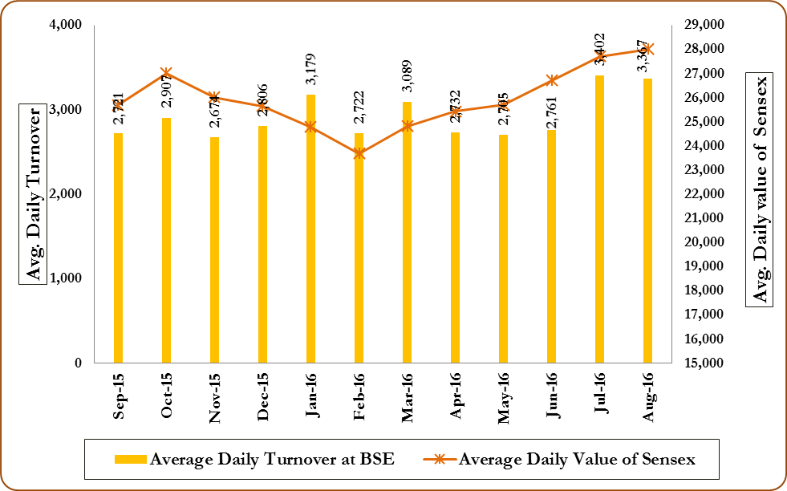

**Figure 3: Trends in Average Daily Values of Nifty and NSE Turnover**

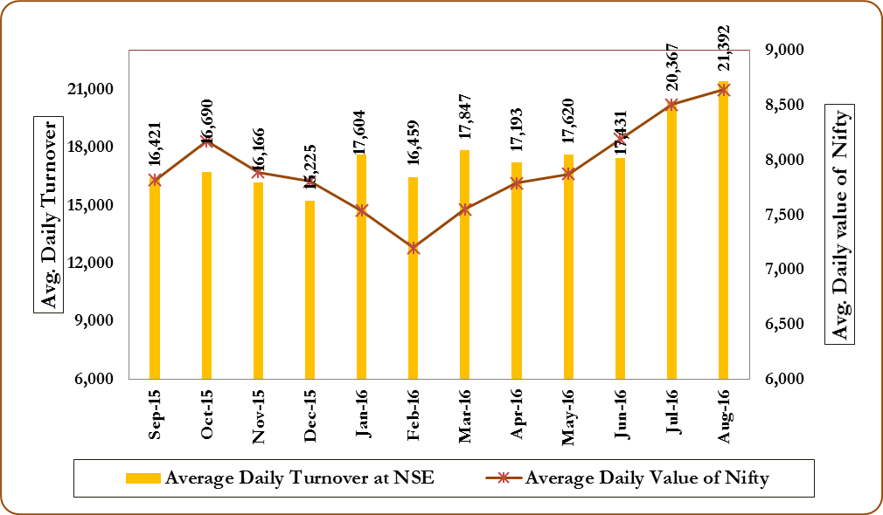

The rally in the prices of equity shares in August 2016 was widespread, with blue-chip indices, broad-based indices and sectoral indices (except Nifty IT, Nifty Pharma, S&P BSE Teck, S&P BSE Capital Goods and S&P BSE Healthcare) all registering gains during the month. Among BSE indices, in August 2016, S&P BSE Metal index increased the most (5.67 percent), followed by S&P BSE Bankex index (4.51 percent) and S&P BSE PSU index (4.45 percent). Among NSE indices, in August 2016, Nifty PSU Bank index increased the most (8.65 percent), followed by Nifty Midcap 50 index (5.60 percent) and Nifty Media index (5.35 percent). During August 2016, the daily volatility of S&P BSE Metal index was the highest at 1.19 percent, followed by S&P BSE Capital Goods index (1.08 percent) and S&P BSE Bankex index (0.94 percent). At NSE during the same period, among all the indices, daily volatility of Nifty PSU Bank index was the highest at 1.89 percent, followed by Nifty IT index (1.04 percent) and Nifty FMCG index and Nifty Media index (both at 1.00 percent) (***Exhibit 3***).

**Exhibit 3: Performance of Indices at BSE and NSE during August 2016 (Percent)**



***Source: BSE and NSE***

1. **Trends in Depository Accounts**

The total number of investor accounts was 149.3 lakh at NSDL and 113.5 lakh at CDSL at the end of August 2016. In August 2016, the number of investor accounts at NSDL and CDSL increased by 0.62 percent and 1.04 percent, respectively, over the previous month. A comparison with August 2015 showed there was an increase in the number of investor accounts to the extent of 6.4 percent at NSDL and 13.3 percent at CDSL **(*Table 58*)**.

1. **Trends in Derivatives Segment**

**A. Equity Derivatives**

India is one of the most vibrant markets for exchange traded equity derivatives in the world. The trading volumes in the equity derivatives market was 13.6 times that of the equity cash segment in August 2016. The monthly total turnover in equity derivatives market at NSE increased by 18.3 percent to `79,23,783 crore in August 2016 from `66,97,728 crore in July 2016 (***Figure 4***). The index options segment has been the clear leader in the product-wise turnover of the futures and options segment at NSE. In July 2016, the turnover in the index options category was 74.6 percent of the total turnover in the F&O segment of the NSE. During August 2016, index futures, index options, stock futures and stock options registered increases in turnover over the previous month. The open interest in value terms in the equity derivative segment of NSE increased by 21.7 percent to `2,50,912 crore as on August 31, 2016 from `2,06,125 crore as on July 31, 2016.

**Figure 4: Trends of Equity Derivatives Segment at NSE (` crore)**

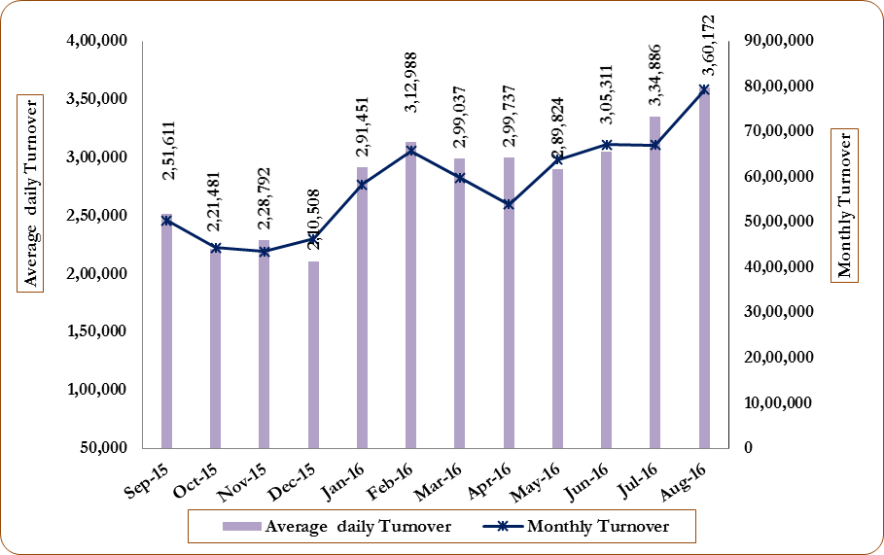

The monthly total turnover in equity derivative segment of BSE increased by 285.1 percent to `1,225 crore in August 2016 from `318 crore in July 2016. The entire turnover was accounted for by index futures and stock futures. The open interest in value terms in equity derivatives segment of BSE increased by 200.6 percent to `20 crore as on August 31, 2016 from `7 crore as on July 31, 2016.

In August 2016, NSE had almost 100.0 percent share in total equity derivatives turnover as well as open interest (in value terms) in India. (***Exhibit 4***).

**Exhibit 4: Trends in Equity Derivatives Market**



**B. VIX Futures at NSE**

NSE introduced futures contracts on India VIX in the Futures & Options segment of NSE w.e.f. February 26, 2014. India VIX is India’s first volatility index which is a key measure of market expectations of near-term. The contract symbol is INDIAVIX and 3 weekly futures contracts were made available for trading. The contracts shall expire on every Tuesday. The tick size is 0.25 and lot size is 550.

India VIX closed at 13.2 for August 2016, lower than 14.9 registered for July 2016 (***Figure 5***). During August 2016, there was no trade in VIX futures contracts at F&O segment of NSE. Consequently, the open interest in India VIX contracts was zero at the end of August 2016.

**Figure 5: Trends in VIX futures at NSE**

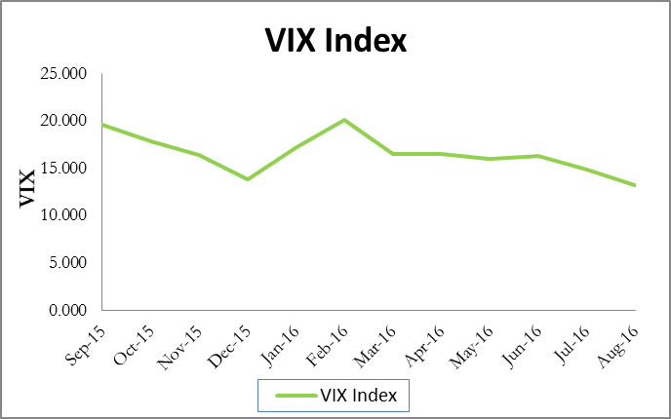

**C. Currency Derivatives at NSE, MSEI and BSE**

During August 2016, the monthly turnover of currency derivatives at NSE increased by 6.6 percent to `3,36,005 crore from `3,15,239 crore in July 2016. The turnover of currency derivatives at BSE increased by 4.2 percent to `2,36,833 crore in August 2016 from `2,27,277 crore in July 2016. At MSEI, the monthly turnover of currency derivatives decreased by 8.7 percent to `27,177 crore in August 2016 from `29,763 crore in July 2016. (***Figure 6*** ***and Tables 37, 38 and 39*)**

Figure 6: Trends of Currency Derivatives at NSE, MSEI and BSE (`crore)

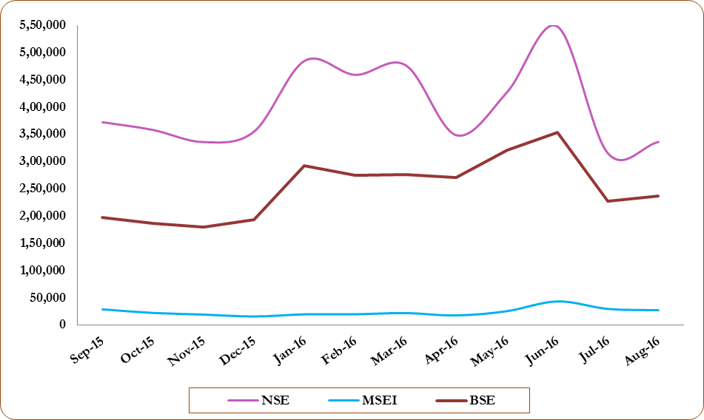

**D. Interest Rate Derivatives at NSE, BSE and MSEI**

During August 2016, the monthly turnover of interest rate futures at NSE increased by 16.7 percent to `22,532 crore from `19,302 crore in July 2016. The turnover of interest rate futures at BSE increased by 3.2 percent to `8,340 crore in August 2016 from `8,080 crore in July 2016. At MSEI, the monthly turnover of interest rate futures decreased to `670 crore in August 2016 from `948 crore in July 2016 (*Figure 7* *and Table 47*).

**Figure 7: Trends of Interest Rate Derivatives at NSE, BSE and MSEI (`crore)**

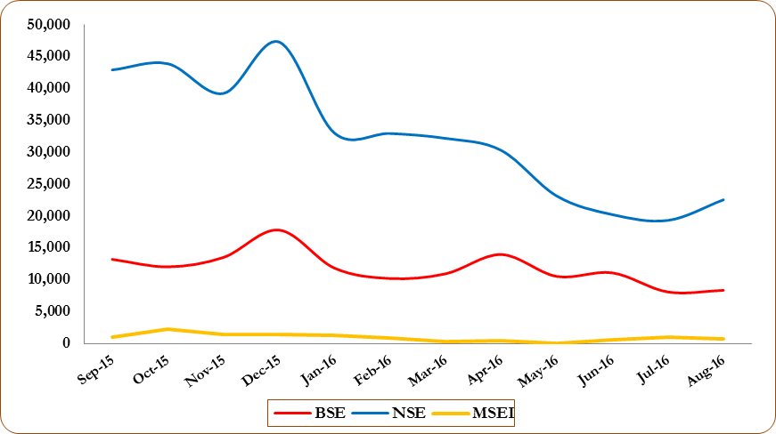

1. **Commodity Derivatives Markets**

A. Market Trends

At end of August 2016, the composite index MCXCOMDEX declined by 0.12 percent while, Dhaanya Index of NCDEX also declined by 4.10 percent over the closing values previous month. On August 31, 2016, MCXCOMDEX and Dhaanya closed at 3087.2 and 3174.5, respectively (***Figure 8***). MCXCOMDEX recorded an intraday high of 3183.63 on August 19, 2016 while 3063.41 on August 03, 2016 was its lowest intra-day level during the month. NCDEX Dhaanya recoded an intra-day high of 3370.24 on August 05, 2016 and an intra-day low of 3136.19 on August 29, 2016. The group indices of MCXCOMDEX, namely, MCX Energy and MCX Agri. increased by 6.70 percent and 0.42 percent, respectively, while that of MCX Metal recorded a fall of 3.37 percent. **(*Tables 61 to 71*)**

**Figure 8: Movement of Commodity Futures Market Indices**

During August 2016, MCXCOMDEX recorded a daily volatility of 0.74 percent, while NCDEX Dhaanya index recorded a daily volatility of 0.69 percent. Among the group indices at MCX, highest volatility of 2.13 percent is observed in MCX Energy, followed by MCX Agri. (0.91 percent) and MCX Metal (0.56 percent). The rolling daily volatility and return over the previous months of commodity futures market indices is shown in the Exhibit 5 below:

**Exhibit 5: Performance of Indices at MCX and NCDEX during August 2016 (Percent)**

|  |  |  |  |  |  |
| --- | --- | --- | --- | --- | --- |
| **MCX** | | | **NCDEX** | | |
| **Index** | **Change over Previous month** | **Daily Volatility** | **Index** | **Change over Previous month** | **Daily Volatility** |
| **1** | **2** | **3** | **4** | **5** | **6** |
| MCXCOMDEX | -0.12 | 0.74 | Dhaanya | -4.10 | 0.69 |
| MCX Metal | -3.37 | 0.56 |  |  |  |
| MCX Energy | 6.70 | 2.13 |  |  |  |
| MCX Agri. | 0.42 | 0.91 |  |  |  |

Source: MCX and NCDEX

The total turnover at MCX was `5,36,804 crore in August 2016, which is a decrease of 6.85 percent over the total turnover of `5,76,310 crore during July 2016. The contribution to the total turnover at MCX from Bullion segment was at 38.67 percent followed by Energy segment at 33.97 percent, metals segment with 24.78 percent and agricultural commodities had a share of 2.59 percent.

The total turnover at NCDEX has decreased from `72,508 crore in July 2016 to `64,268 crore in August 2016, indicating a decline of 11.4 percent. The entire turnover at NCDEX since last three months is contributed by the agricultural commodities segment only.

The total turnover at NMCE has decreased from `2,219 crore in July 2016 to `2,155 crore in August 2016, indicating a decline of 2.8 percent. The entire turnover at NMCE is also contributed by the agricultural commodities segment only.

The total turnover in agricultural commodities at all the three national exchanges stood at `80,308 crore while that of the non - agricultural commodities stood at `5,22,920 crore. The total turnover of agricultural commodities was the highest at NCDEX (`64,268 crore) followed by MCX (`13,884 crore) and NMCE (`2,155 crore) (Figure 9). The total turnover of non-agricultural commodities was `5,22,920 crore at MCX. (Figure 10). Details in Table 63, 64, & 65.

Among the regional exchanges, Rajkot Commodity Exchange Ltd. (RCE) recorded a total turnover of `89.87 crore during August 2016 as compared to `189.81 crore recorded during the previous month. Only one castor seed contract is being traded at RCE, Rajkot. The Chamber of Commerce (CoC), Hapur recorded a total turnover of `1159.59 crore during August 2016, a decrease of 3.57 percent over the previous month’s total turnover of `1,202.56 crore. Only one mustard seed contract is being currently traded at CoC, Hapur. The Indian Pepper and Spice Trade Association (IPSTA), Kochi where contracts of only pepper are traded, recorded a nil turnover during the month.

**Figure 9: Turnover of Agricultural Commodities Futures at Exchanges (`crore)**

**Figure 10: Turnover of Non-Agricultural Commodities Futures at Exchanges (`crore)**

**Exhibit 6: Periodic Variation (M-o-M and Y-o-Y) in futures closing prices for near month contracts of commodities traded at MCX and NCDEX**

|  |  |  |  |  |  |
| --- | --- | --- | --- | --- | --- |
| **Commodities traded at MCX** | **Variation in prices as on August 31, 2016 (percent)** | | **Commodities traded at NCDEX** | **Variation in prices as on August 31, 2016 (percent)** | |
| **M-o-M** | **Y-o- Y** | **M-o-M** | **Y-o- Y** |
| Gold | -2.61% | 15.15% | Guar seed 10 MT | -7.02% | -16.22% |
| Gold M | -1.14% | 15.85% | Guar Gum | -5.91% | -33.37% |
| Gold Petal | -0.36% | 16.57% | Soybean | -8.43% | 0.96% |
| Gold Guinea | -0.16% | 17.20% | Turmeric | -10.47% | -14.44% |
| Silver | -7.35% | 27.20% | Sugar | -6.18% | 44.45% |
| Silver Mini | -7.36% | 27.19% | Rape/Mustard seed | -3.70% | 8.38% |
| Silver Micro | -7.37% | 27.21% | Soy Oil | 2.01% | 11.36% |
| Silver 1001 | -5.72% | 26.22% | Rabi Maize | -2.09% | 7.91% |
| Nickel | -7.23% | -2.60% | Maize Kharif | 3.68% | 2.13% |
| Nickel Mini | -7.26% | -2.69% | Cotton seed oil cake | 0.93% | 27.14% |
| Copper | -7.31% | -10.59% | Cotton 29mm | -10.51% | 19.60% |
| Copper Mini | -7.32% | -10.59% | Wheat | 2.22% | 15.60% |
| Lead Mini | 5.07% | 8.24% | Jeera | -9.87% | 9.43% |
| Euro Lead | 5.06% | 8.24% | Coriander | -2.11% | -22.65% |
| Crude Oil | 7.94% | -7.03% | Barley | -4.75% | 26.36% |
| Crude Brent | 12.83% | 4.87% | Chilly | 1.67% | 33.90% |
| Natural Gas | 0.78% | 8.79% | V797 Kapas | -15.33% | NA |
| Cardamom | 18.66% | 33.40% |  |  |  |
| Zinc | 4.43% | 28.24% |  |  |  |
| Zinc Mini | 4.46% | 28.33% |  |  |  |
| Aluminium | -1.15% | 0.05% |  |  |  |
| Aluminium Mini | -1.20% | 0.05% |  |  |  |
| Cotton | -10.00% | 20.23% |  |  |  |
| CPO | 6.65% | 55.19% |  |  |  |
| Mentha Oil | 0.46% | -7.88% |  |  |  |
|  |  |  |  |  |  |

At the end of August 2016, M-o-M returns among the near month contracts traded at exchanges indicated a mixed trends. Among the non-agricultural commodities, the top gainers in terms of futures prices were Crude Brent (12.8 percent), Crude Oil (7.9 percent), Lead Mini (5.1 percent) and Zinc Mini (4.5 percent), while maximum decline was recorded in futures prices of Silver (5.7 percent to 7.4 percent). It was followed by Copper, Copper Mini (7.3 percent), Nickel (and Nickel Mini (7.2 percent), Gold (2.6 percent) and Aluminum (1.2 percent).

Among the agricultural commodities, the M-o-M upward trend is observed in the near month contract of Cardamom (18.7 percent) followed by Crude Palm Oil (6.7 percent), Maize Kharif (3.7 percent), Wheat (2.2 percent), Chilly (1.7 percent), Cotton seed oil cake (0.9 percent) and Mentha Oil (0.5 percent), while futures prices declined the most in contract of V797 Kapas ((15.3 percent) followed by Cotton 29 mm and Turmeric (10.5 percent each), Cotton (10.0 percent), Jeera (9.9 percent), Soyabean (8.4 percent) and Guar Seed 7.0 percent).

On Y-o-Y basis, top gainers among non-agricultural commodities were contracts of Silver (26.2 percent to 27.2 percent), Gold (15.2 percent to 17.2 percent), Zinc Mini (28.3 percent), Zinc (28.2 percent) and Aluminum (20.2 percent) , while among agricultural commodities, price of Crude Palm Oil recorded highest increase of 55.2 percent followed by Sugar (44.5 percent), Chilly (33.9 percent), Cotton Seed Oilcake (27.1 percent), (Barley (26.4 percent), Cotton 29 mm (19.6 percent), Wheat(15.6 percent), Soy oil (11.4 percent), etc. Only contracts of Guar Gum and Coriander recorded Y-o-Y losses of 33.4 percent and 22.7 percent, respectively.

**B. Progress of Sowing of Kharif crops**

1. As per latest information available on sowing of crops, around 99% of the normal area under Kharif crops has been sown up to September 16, 2016. Total area sown under Kharif crops in the country has been reported to be 1059.48 lakh hectares as compared to 1022.61 lakh hectares last year. This year’s area coverage so far is higher by 36.9 lakh hectares than the area coverage during the corresponding period of last year and by 44.4 lakh hectares than normal area coverage during the same period.
2. The following are the key highlights on the progress of sowing of kharif crops as on September 16, 2016 :

* Area coverage under Kharif Pulses is higher by 32.5 lakh hectares than the last year and by 39.1 lakh hectares than normal as on date. This is due to higher coverage in Tur, Urad and Moong.
* Area coverage under Kharif coarse cereals is higher by 5.9 lakh hectares than last year and by 5.2 lakh hectares normal as on date. This is due to higher coverage of 83.22 hectares in Maize. This year, sowing under maize is 11.5 percent more than the normal as on date and 8.6 percent more as compared with last year.
* Area coverage under total Kharif Oilseeds is higher by 5.1 lakh hectares than the last year and by 7.3 lakh hectares than normal as on date. This is due to higher coverage in Groundnut. However, sowing under Castor Seed is reported at 8.15 lakh hectares as compared with 10.42 normal as on date, which is 21.8 percent less.
* Area coverage under Sugarcane is lower by 3.8 lakh hectares than the last year and by 0.4 lakh hectares than normal as on date.
* Area coverage under Cotton is lower by 13.0 lakh hectares than the last year and by 15.5 lakh hectares than normal as on date.
* Area coverage under Kharif Rice is higher by 10.3 lakh hectares than the last year and 9.3 lakh hectares than normal as on date.

1. All India Crop Situation - Kharif (2016-17) as on September 16, 2016 for exchange traded/permitted to trade commodities is as under:

**Exhibit 7 : Progress of sowing (kharif)**

*(in lakh hectare)*

|  |  |  |  |  |  |  |  |
| --- | --- | --- | --- | --- | --- | --- | --- |
| **Crop Name** | **Normal Area for whole Kharif Season** | **Normal Area as on date** | **Area Sown Reported** | | | **Absolute Change over (+/-)** | |
| **This year 2016** | **% of Normal for whole season** | **Last Year 2015** | **Normal as on date** | **Last year** |
| Bajra | 81.63 | 70.01 | 70.42 | 86.3 | 70.40 | 0.4 | 0.0 |
| Maize | 73.50 | 74.65 | 83.22 | 113.2 | 76.34 | 8.6 | 6.9 |
| Soybean | 106.36 | 111.80 | 114.71 | 107.9 | 116.22 | 2.9 | -1.5 |
| Castor Seed | 11.48 | 10.42 | 8.15 | 71.0 | 10.83 | -2.3 | -2.7 |
| Cotton | 120.34 | 117.74 | 102.23 | 85.0 | 115.20 | -15.5 | -13.0 |
| Sugarcane | 49.96 | 46.21 | 45.77 | 91.6 | 49.60 | -0.4 | -3.8 |
| Jute & Mesta | 8.57 | 8.12 | 7.57 | 88.3 | 7.73 | -0.5 | -0.2 |

*Source: Crops and TMOP Division, Dept. of Agriculture Co-operation and Farmers’ Welfare*

1. Pest & Diseases:

* Incidence of Red hairy caterpillar, White fly, Thrips & Yellow mosaic virus on Moong & Moth have been reported in trace to moderate intensity in Sujangarh, Sardarshar, Rajgarh, Taranagar & Bidasar blocks of Churu district and Nohar & Bhadara blocks of Hanumangarh district of Rajasthan. The crops stages are vegetative to flowering.
* Incidence of Red hairy caterpillar, White fly, Thrips, Yellow mosaic virus & Wilt on Guwar have been reported in trace to moderate intensity in Sujangarh, Sardarshar, Rajgarh, Taranagar & Bidasar blocks of Churu distric and Nohar block of Hanumangarh district of Rajasthan. The crops stages are vegetative to flowering.
* Incidence of Pink boll worm on cotton has been reported in low to moderate intensity in Anantapur district of Andhra Pradesh. The crop stage is flowering to ball formation.
* No shortage of Chemical / Bio-pesticides was reported from any State / UT

*Reference*: *Weather Watch Group, Department of Agriculture Cooperation* & *Farmers’ Welfare*

1. **Trading in Corporate Debt Market**

During August 2016, 2,029 trades with a traded value of `19,400 crore was reported on BSE compared to 1,857 trades with a traded value of `16,187 crore reported in July 2016. At NSE, 5,402 trades were reported in August 2016 with a traded value of `90,213 crore compared to 5,453 trades with value of `92,599 crore in July 2016 ***(Figure 11 and Table 13*)**.

**Figure 11: Trends in Reported Turnover of Corporate Bonds (**` **crore)**

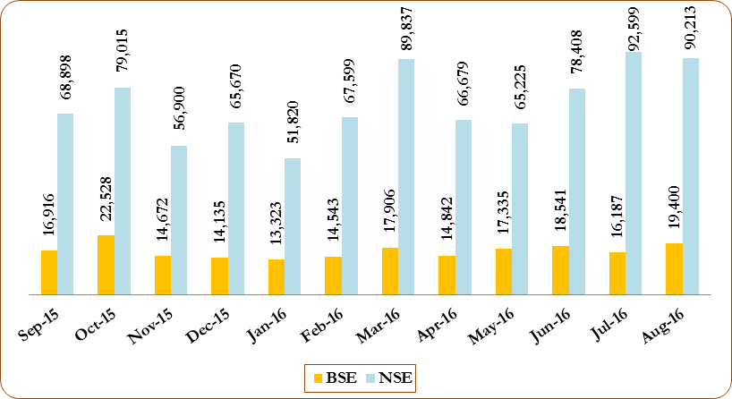

1. **Trends in Institutional Investment**
2. **Trends in Investment by Mutual Funds**

The total net investment in the secondary market by mutual funds was `6,810 crore in August 2016 compared to `19,619 crore in July 2016. They made net purchases of `2,717 crore in equity in August 2016 compared to net sales of `34 crore in equity in July 2016. In the debt segment, mutual funds were net purchasers to the tune of `4,093 crore in August 2016 as against net purchases of `19,653crore made by them in July 2016 (***Figure 12***).

As on August 31, 2016, there were a total of 2,404 mutual fund schemes of which income/debt oriented schemes were 1,810 (75.3 percent), growth/equity oriented schemes were 473 (19.7 percent), exchange traded funds with 64 schemes (2.7 percent), fund of funds investing overseas schemes were 29 (1.2 percent) and balanced schemes were 28 (1.2 percent). **(*Tables 55 & 56*).**

**Figure 12: Trends in Mutual Funds Investment (` crore)**

1. **Trends in Investment by the Foreign Portfolio Investors (FPIs)**

In August 2016, the FPIs turned to be net buyers in the Indian securities market to the tune of `6,446 crore. There were net inflows in equity segment to the tune of `9,071 crore while debt segment witnessed a net outflow of `2,625 crore (***Figure 13***).

The assets of the FPIs in India, as reported by the custodians, at the end of August 2016 stands at `25,65,304 crore, out of which the value of offshore derivative instruments (including ODIs on derivatives) is `2,16,232 crore, constituting 8.4 percent of the total assets under custody of FPIs. (***Tables 49, 50 & 51***)

**Figure 13: Trends in FPIs Investment (` crore)**

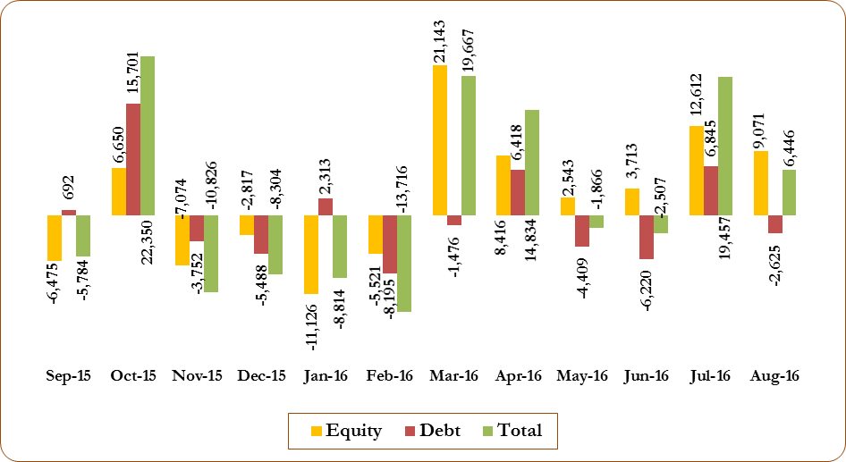

1. **Trends in Portfolio Management Services**

Total assets under management (AUM) of portfolio management services (PMS) industry has increased by 1.6 percent to `11,36,941 crore in August 2016 from `11,19,373 crore in July 2016. As on August 31, 2016, AUM of discretionary PMS constitute 76.8 percent of the total AUM of PMS followed by advisory PMS (17.3 percent) and non-discretionary PMS (5.9 percent).

In terms of number of clients, discretionary services category leads with total of 56,174 clients, out of 62,882 clients in PMS industry, followed by non-discretionary category with 4,435 clients and advisory category with 2,273 clients. ***(Table 57)***

1. **Trends in Substantial Acquisition of Shares and Takeovers**

In August 2016, six open offers with offer value of `2,470 crore were made to the shareholders as against seven open offers with offer value of `2,692 crore in July 2016 (***Figure 14***).

**Figure 14: Details of Offers Opened under the SEBI (SAST) Regulations (` crore)**

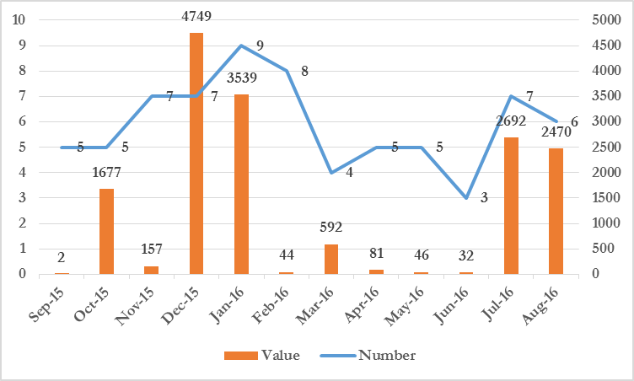

**MONTHLY REVIEW OF GLOBAL FINANCIAL MARKETS[1]**

1. **Introduction:**

**Snapshots**

**United States:**

The US economy grew by 1.1 percent (Q-o-Q) (in annualised terms) in Q2 of 2016 compared to a growth rate of 1.2 percent in Q1 of 2016. Consumer prices in the US went up by 1.1 percent (Y-o-Y) in August 2016, as compared to July 2016. The unemployment rate remained stable at 4.9 percent in August 2016, compared to previous month.

**United Kingdom**

The UK economy advanced 2.2 percent (Y-o-Y) in Q2 2016, up from 2 percent recorded in Q1 2016. Monthly CPI inflation was 0.6 percent in August 2016, down from 0.2 percent in previous month. The unemployment rate slowed down to 4.9 percent in August 2016, the lowest since July 2005.

**Japan:**

The Japanese economy grew by 0.6 percent (Y-o-Y) in Q2 2016, as compared to 0.2 percent during Q1 of 2016. Consumer prices declined 0.5 percent year on year while the unemployment rate slowed down to 3.0 percent.

**Euro Zone (EA19):**

The Euro zone economy grew by 1.6 percent (Y-o-Y) in Q2 2016, down from 1.7 percent in Q1 2016. Consumer prices in the Euro Area rose by 0.2 percent Y-o-Y, as compared to the prices in previous month. Unemployment rate in the EA19 remained stable at 10.1 percent in June 2016.

**BRIC Nations:**

* Real GDP of Brazil contracted by 3.8 percent (Y-o-Y) in Q2 2016, compared to 5.4 percent contraction in Q1 of 2016. CPI inflation accelerated to nearly 9 percent in August as compared to 8.7 percent in previous month. Brazil's unemployment rate remained unchanged at 11.6 percent at the end of July 2016.
* The Russian economy contracted for the sixth successive quarter as real GDP of Russia fell by 0.6 percent (Y-o-Y) in Q2 of 2016. CPI inflation was 6.9 percent in August, down from 7.2 percent in July 2016. Unemployment rate decreased slightly to 5.2 percent in August 2016 from 5.3 percent in July 2016.
* India’s real GDP grew by 7.1 percent (Y-o-Y) in Q1 of FY 2016 (new series) as compared 7.9 percent in the previous quarter. IIP shrank by 2.4 percent in July 2016, as compared to an expansion of 2.1 percent in the previous month. Consumer prices inflation slowed marginally to 5.1 percent, down from 6.1 percent in July 2016.
* During Q2 2016, real GDP of China remained constant at 6.7 percent (Y-o-Y), as compared to Q1 of 2016. CPI inflation moved down slightly to 1.3 percent (Y-o-Y) in August 2016, from 1.8 percent in the previous month.
  1. International stock markets displayed moderate growth during the month, as investor sentiments toward equities remained a little subsided amid a prevailing low interest rate environment.
  2. Global financial markets around the world embarked on a path to recovery during August as uncertainty following Brexit waned.
  3. Prevalence of negative/ low government debt yields across developed economies pushed demand for higher yielding assets in favour of emerging markets as August came to an end.
  4. Emerging equity markets outperformed developed equity markets, with the MSCI Emerging Market Index returning a monthly gain of 2.31 percent in August 2016 whereas the MSCI World Market Index declined by -0.13 percent at the close of the month.
  5. US equities advanced marginally in August as expectations of Fed Reserve increasing their rates gained strength. The S&P 500 increased slightly, by 0.1 percent. Early gains in the beginning of the month were short lived. Fed Chair Janet Yellen conveyed the message of a foreseeable increase in base rates.
  6. Eurozone equities registered a positive return in August as the overall Eurozone economy grew at 0.3 percent (Q-on-Q) during the second quarter. Annual inflation was approximately 0.2 percent, remaining unchanged since July, which is why the European Central Bank is expected to be coming up with a further stimulus.
  7. UK equities fared well during August as the Bank of England (BoE) came out with a number of much needed monetary easing measures in the wake of uncertainty following Brexit. In the beginning of August, the central bank announced a drop in its benchmark interest rate to 0.25 percent from 0.50 percent. Meanwhile in its latest Quarterly inflation report, the BoE significantly reduced UK’s 2017 GDP growth forecast from 2.3 percent (pre-Brexit) to a mere 0.8 percent.
  8. Bank of England unveiled a series of extensive easing measures supporting gilts. A broadly positive environment for macroeconomic data in the Eurozone and US led to modest gains in euro and dollar credit markets. The emerging market debt also recorded gains, where all principal market components generated positive returns. August turned out to a second consecutive month, where corporate bonds enjoyed more than expected positive gains.
  9. India’s Q2 2016 GDP growth slowed significantly, growing 7.1 percent year-on-year (Y-o-Y) compared to 7.9 percent in Q1, in the face of an expected growth rate of 7.6 percent. The government’s preferred measure, Gross Value Added or GVA (GDP plus taxes and less subsidies) indicated better growth, despite slipping to 7.3 percent (Y-o-Y) from 7.4 percent in the previous quarter. On the other hand, Brazil exceeded expectations, as the economy recovered with a contraction rate of 3.8 percent year-on-year compared to the 5.4 percent contraction recorded in Q1.
  10. According to latest IMF projections in the *World Economic Outlook* (WEO), India is projected to grow at 7.4 percent in 2016 and 2017, while China is projected to grow at 6.6 percent in 2016 and 6.2 percent in 2017.
  11. According to latest World Bank projections in the *Global Economic Prospects* (GEP), India is projected to grow at 7.8 percent in 2016 and 7.9 percent in 2017, while China is projected to grow at 6.7 percent in 2016 and 6.5 percent in 2017.
  12. According to the latest IMF projections in the WEO, advanced economies are projected to grow by 1.8 percent in 2016 as well as in 2017, while the growth in Emerging Market and Developing Economies (EMDEs) is projected at 4.1 percent and 4.6 percent for 2016 and 2017 respectively. The overall world output is projected at 3.1 percent in 2016 and 3.4 percent in 2017. Post-Brexit, these projections were marked down in the wake of global implications that would follow. The baseline global growth was revised relative to April 2016 WEO (down by 0.1 percentage points for 2016 and 2017, in contrast to a 0.1 percentage point upward revision for 2017 envisaged pre-Brexit).

1. **Major Recent Developments Across the Globe:**
   1. **Japan's economy stalls in Q2 of 2016**
      1. As per the Japan's cabinet office data, the world's third-largest economy (as a country, excluding EU) expanded by 0.2 percent (annualized) in the second quarter, lower than the 0.7 percent increase markets had expected.
      2. The above figure indicates a sharp slowdown from a (revised) 2.0 percent increase in January-March, according to Cabinet Office data released on 15th August 2016.
      3. Private consumption, which contributes approximately 60 percent to Japan’s GDP, rose 0.2 percent, slowing from a 0.7 percent increase in the previous quarter.
   2. **British economy didn’t show any signs of Brexit blow, for now**
      1. In August, retail sales reversed much of the post-Brexit fall, with retailers reporting their strongest sales in six months, according to industry data released on 25th August 2016.
      2. Markets were booming with shoppers despite June's shock vote to leave the European Union, and big companies have reported few signs of distress, leading to speculations about a post-Brexit economic boom.
      3. Nearly half of mortgage borrowers seem to have gained from the Bank of England's rate cut on 4 August 2016, and British equity markets have risen.
   3. **Canadian economy has biggest quarterly drop in seven years**
      1. Hurt by a drop in exports and a disruption to oil production caused by wildfires in Alberta, Canada's economy shrank in the second quarter, its worst showing in seven years.
      2. *Statistics Canada* reported that GDP contracted by 1.6 percent (annualized) in the second quarter.
      3. It overshot expectations of a 1.5 percent contraction, and was the biggest annualized decline since the second quarter of 2009, when Canada was in crisis-induced recession.

**The World Economy:**

* 1. **Global growth**: The International Monetary Fund cut its global growth forecast this year and the next as the unexpected U.K. vote to leave the European Union created a wave of uncertainty amid already fragile business and consumer confidence. It may yet have negative macroeconomic consequences, especially in the advanced European economies. IMF’s global growth forecasts for 2016 and 2017 were both marked down by 10 basis points relative to the April 2016 WEO, to 3.1 percent and 3.4 percent respectively.

The World Bank revised down its global growth forecast for 2016 by 50 basis points to 2.4 percent, from 2.9 percent projected in January 2016. The move is due to sluggish growth in advanced economies, stubbornly low commodity prices, weak global trade, and diminishing capital flows.

* 1. **Growth in Advanced Economies**: According to IMF projections, among advanced economies, the United Kingdom is going to experience the largest downward revision in its growth forecast. The Brexit has significantly weakened domestic demand and hampered growth. The impact of Brexit is projected to be muted for the United States, as lower long-term interest rates and a more gradual path of monetary policy normalization are expected to broadly offset larger corporate spreads, a stronger U.S. dollar, and some decline in confidence. The direct impact of the Brexit vote on China will likely be limited, in light of China’s low trade and financial exposure to the United Kingdom. In the Euro area, delays in tackling legacy issues in the banking sector, however, continue to pose downside risks to the forecast.

According to the World Bank, growth in major advanced economies has deteriorated amid weak global trade and manufacturing activity. Growth is now expected to remain stagnant in 2016, despite the positive effects on real incomes from lower oil prices and improving labour market conditions. Rising or high public debt and monetary policy rates at/near the zero lower bound could reduce the effectiveness of counter-cyclical policies, leaving these economies more vulnerable to domestic and external shocks. The Bank also expressed its concerns regarding the aftermath of Britain’s exit from the European Union. It will push capital away from the region and toward key safe-haven markets including the US—especially Treasuries—and to Japan.

* 1. **Growth in Developing Countries**: IMF projects that growth in emerging market and developing economies will continue to account for the lion’s share of projected world growth in 2016, with prospects across countries remaining uneven and generally weaker than over the past two decades. Brazil and Russia shows signs of moderate growth following the rebound in oil prices. While global industrial activity and trade have been lacklustre amid China’s rebalancing and generally weak investment in commodity exporters, recent months have seen some pick-up due to stronger infrastructure investment in China and higher oil prices.

According to the World Bank, emerging market and developing economies are facing stronger headwinds, including weaker growth among advanced economies and persistently low commodity prices, as well as lacklustre global trade and capital flows. Divergences between commodity exporters and importers persist. Conditions remain markedly challenging for commodity exporters, who continue to struggle to adjust to the new era of depressed prices. In contrast, commodity importers are showing greater resilience to headwinds, although the expected growth windfall from low energy prices has been surprisingly modest. Global growth is projected to pick up slowly to 3 percent by 2018, as stabilizing commodity prices provide support to commodity exporting emerging markets and developing economies.

* 1. **Growth in India**: The economic growth in India remains buoyant but the growth forecast of India for 2016-17 was trimmed slightly by IMF to 7.4 percent from 7.5 percent projected in April, due to sluggish investment recovery. Tailwinds to consumption should drive another year of healthy growth in India’s economy. The country is in a solid position to withstand the economic impact of the recent global uncertainty caused by the UK’s vote to leave the EU and any subsequent effect, as the Indian economy is driven mainly by domestic demand.

The World Bank projected that India will grow by a robust 7.8 percent in 2016 and 7.9 percent in the next two years. The Bank also predicted that India will be the fastest growing economy in the world in the next three years and would outpace China. With the recent fall in oil prices, India remains the bright spot of the global economy as Chinese growth is predicted to slow further.

**Exhibit 1: Overview of the World Economic Outlook Projections: August 2016**

|  |  |  |  |  |  |  |
| --- | --- | --- | --- | --- | --- | --- |
|  | Year over Year | | | | | |
| **2014** | **2015** | Projections | | Difference from April 2016 WEO Update1 | |
|
| **2016** | **2017** | **2016** | **2017** |
| **World Output 2** | **3.4** | **3.1** | **3.1** | **3.4** | –0.1 | –0.1 |
| **Advanced Economies** | **1.8** | **1.9** | **1.8** | **1.8** | –0.1 | –0.2 |
| United States | 2.4 | 2.4 | 2.2 | 2.5 | –0.2 | 0 |
| Euro Area | 0.9 | 1.6 | 1.6 | 1.4 | 0.1 | –0.2 |
| Germany | 1.6 | 1.5 | 1.6 | 1.2 | 0.1 | –0.4 |
| France | 0.2 | 1.1 | 1.5 | 1.2 | 0.4 | –0.1 |
| Italy | -0.3 | 0.8 | 0.9 | 1 | –0.1 | –0.1 |
| Spain | 1.4 | 3.2 | 2.6 | 2.1 | 0 | –0.2 |
| Japan | 0 | 0.5 | 0.3 | 0.1 | –0.2 | 0.2 |
| United Kingdom | 2.9 | 2.2 | 1.7 | 1.3 | –0.2 | –0.9 |
| Canada | 2.5 | 1.2 | 1.4 | 2.1 | –0.1 | 0.2 |
| Other Advanced Economies 3 | 2.8 | 2 | 2 | 2.3 | –0.1 | –0.1 |
| **Emerging Market and Developing Economies** | **4.6** | **4** | **4.1** | **4.6** | 0 | 0 |
| Emerging and Developing Asia | 6.8 | 6.6 | 6.4 | 6.3 | 0 | 0 |
| ASEAN-5 5 | 4.6 | 4.7 | 4.8 | 5.1 | 0 | 0 |
| Emerging and Developing Europe | 2.8 | 3.5 | 3.5 | 3.2 | 0 | –0.1 |
| **BRICS Nations** |  |  |  |  |  |  |
| Brazil | 0.1 | -3.8 | -3.3 | 0.5 | 0.5 | 0.5 |
| Russia | 0.7 | -3.7 | -1.2 | 1 | 0.6 | 0.2 |
| **India 4** | **7.2** | **7.3** | **7.4** | **7.4** | –0.1 | –0.1 |
| China | 7.3 | 6.9 | 6.6 | 6.2 | 0.1 | 0 |
| South Africa | 1.5 | 1.3 | 0.1 | 1 | –0.5 | –0.2 |

***Note****: Real effective exchange rates are assumed to remain constant at the levels prevailing during June 24–June 28, 2016. Economies are listed on the basis of economic size. The aggregated quarterly data are seasonally adjusted.*

*1Difference based on rounded figures for both the current and April 2016 World Economic Outlook forecasts.*

*2Countries included in the calculation of quarterly estimates and projections account for approximately 90 percent of world GDP at purchasing power parities.*

*3Excludes the G7 (Canada, France, Germany, Italy, Japan, United Kingdom, United States) and euro area countries.*

*4For India, data and forecasts are presented on a fiscal year basis and GDP from 2011 onward is based on GDP at market prices with FY2011/12 as a base year.*

*5Indonesia, Malaysia, Philippines, Thailand, Vietnam*

***Source****: IMF*

**Exhibit 2: Major Macroeconomic Indicators**

|  |  |  |  |  |  |  |  |  |  |  |
| --- | --- | --- | --- | --- | --- | --- | --- | --- | --- | --- |
|  | **Country / Region** | **Quarterly Growth Real GDP** | | | | **Annual CPI Inflation** | | **Unemployment Rate** | | **Benchmark Interest Rate** |
|  | **YOY** | | **QOQ** | |
| **Developed**  **Countries** | United States | 1.2 | Q2 | 1.2 | Q2 | 1.1 | Aug-16 | 4.9 | Aug-16 | 0.5 |
| United Kingdom | 2.2 | Q2 | 0.6 | Q2 | 0.3 | Aug-16 | 4.9 | Jul-16 | 0.3 |
| Germany | 3.1 | Q2 | 0.4 | Q2 | 0.4 | Aug-16 | 6.1 | Aug-16 | -0.4 |
| France | 1.4 | Q2 | 0.7 | Q1 | 0.2 | Aug-16 | 9.9 | Jun-16 | -0.4 |
| Eurozone | 1.6 | Q2 | 0.3 | Q2 | 0.2 | Aug-16 | 10.1 | Jul-16 | -0.4 |
| Japan | 0.6 | Q2 | 0.5 | Q1 | -0.5 | Jul-16 | 3.0 | Jul-16 | -0.1 |
| Hong Kong | 1.7 | Q2 | 1.6 | Q2 | 2.3 | Jul-16 | 3.4 | Jun-16 | 0.75 |
| **BRICS** | Brazil | -5.4 | Q1 | -0.3 | Q1 | 8.9 | Aug-16 | 11.6 | Jul-16 | 14.3 |
| Russia | 0.6 | Q2 | -0.6 | Q2 | 6.9 | Aug-16 | 5.2 | Aug-16 | 10.0 |
| India | 7.9 | Q1 | 7.9 | Q1 | 5.0 | Aug-16 | NA | Jul-16 | 6.5 |
| China | 6.7 | Q2 | 6.7 | Q2 | 1.3 | Aug-16 | 4.0 | Jun-16 | 4.4 |
| **Other Ems** | South Korea | 3.2 | Q2 | 0.7 | Q2 | 0.4 | Aug-16 | 3.6 | Aug-16 | 1.3 |
| Indonesia | 5.1 | Q2 | 4.0 | Q1 | 2.8 | Aug-16 | 5.5 | Mar-16 | 6.5 |
| Turkey | 4.8 | Q1 | -7.0 | Q2 | 8.0 | Aug-16 | 10.2 | Jun-16 | 7.5 |

***Note:*** *Q2 represents the second Quarter of 2016. (*) represents figure in annualised terms.*

***Source:*** *Bloomberg*

**Chart 1: Year-on-Year Real GDP growth rates of major countries/ region (percent)**

***Source:*** *Bloomberg*

**Chart 2: Year-on-Year Consumer Price Inflation (percent)**

***Source:*** *Bloomberg*

## United States:

* 1. Real gross domestic product (GDP) growth rate was at 1.1 percent (Q-o-Q) (in annualised terms) for the second quarter of 2016, according to the advance estimate released by the Bureau of Economic Analysis. In the first quarter, real GDP increased by 0.8 percent.

**Chart 1A: USA GDP growth rate (Q-o-Q) Annualised**

* 1. The increase in real GDP in the second quarter mainly reflected positive contributions from personal consumption expenditures (PCE) and exports that were partly offset by negative contributions from private inventory investment, residential fixed investment, and state and local government spending and non-residential fixed investment. Imports, which are a subtraction in the calculation of GDP, increased.
  2. Real Annual GDP increased 2.4 percent (Y-o-Y) in 2015, the same rate as in 2014. The World Bank has revised its GDP growth estimate from 2.7 to 1.9 percent for 2016. IMF also revised its GDP growth projections from 2.4 to 2.2 percent for 2016; whereas the projection for 2017 was unchanged at 2.5 percent.
  3. The seasonally adjusted final Markit U.S. Manufacturing Purchasing Managers’ Index™ (PMI™) registered a value of 52.0 in August, lower than 52.9 in July but comfortably above the stagnant 50.0 mark. The latest PMI reading was fractionally lower than the earlier flash estimate of 52.1 and signalled a weaker improvement in overall business conditions than its average since inception of the survey in late-2009 (54.0). At 51.0 in August, the seasonally adjusted Markit final U.S. Services Business Activity Index dropped from 51.4 in July but remained above the 50.0 for the sixth consecutive month. As per data released by the Bureau of Labor Statistics, the consumer prices in USA went up by 1.1 percent (Y-o-Y) in August 2016, above than the previous month. On a monthly basis it went up by 0.2 percent. Unemployment rate in the US remained 4.9 percent in the August, same as it was in June and July.

***Observations:*** *The revision in GDP growth rates reflected weaker state and local government spending, along with weak inventory investment and higher imports, which were partly offset by upward revisions to non-residential fixed investment and to consumer spending. Wages and salaries for the second quarter are estimated to have increased. Consumer spending, which makes up more than two-thirds of U.S. economic activity, rose at a brisk a 4.4 percent -- the fastest since the fourth quarter of 2014.*

## United Kingdom:

* 1. The British economy is estimated to have grown at 2.2 percent (Y-o-Y) in Q2 of 2016, 20 basis points up from the previous quarter. Largely fuelled by services, mining and industrial production, which expanded at a faster pace while construction fell for the first time in three years, preliminary estimates showed. On a quarter-on-quarter basis, the economy expanded by 0.6 percent, 20 basis points up from 0.4 percent in previous quarter.
  2. During 2015, UK's economy grew 2.2 percent (Y-o-Y), down from 2.9 percent in 2014. The World Bank has revised downwards GDP growth forecast from 2.4 percent to 2.0 in 2016, in its June report, while the IMF has conservatively projected growth of 1.7 percent for 2016 and 1.3 percent for 2017.
  3. Manufacturing PMI was 53.3 in August, the seasonally adjusted Markit/CIPS Purchasing Managers’ Index recovered sharply from the three year low of 48.3 posted in July following the EU referendum. The Business Activity Index rebounded to 52.9 in August, from 47.4 in July, signalling a rise in services output. CPI Inflation in the UK stood at 0.6 percent (Y-o-Y) in August 2016, unchanged from the previous month.
  4. Bank of England’s Monetary Policy Committee (MPC), at its meeting in August 2016, directed monetary policy to meet the 2 percent inflation target, and in a way that helps to sustain growth and employment. They introduced a cut of 25 basis points in the official Bank Rate paid on commercial bank reserves to 0.25 percent and decided to continue the stock of asset purchases, financed by the issuance of central bank reserves at £435 billion. As per the latest available data, the unemployment rate of the economically active population in UK remained at 4.9 percent consecutively for 3 months.

***Observations:*** *The Office for National Statistics reported households increased their spending in the second quarter by the most since before the financial crisis. Their chief economist further said that survey results, which include the period leading up to and immediately following the referendum, show no sign of uncertainty having significantly affected investment or GDP so far. There have been signs that Britain's economy did not suffer an immediate sharp slowdown after the Brexit vote, mostly thanks to continued spending by consumers.*

## Japan:

* 1. The Japanese economy unexpectedly remained stagnant in the June quarter of 2016, following a 0.5 (Q-o-Q) percent expansion in the first quarter and market expectations of a 0.2 percent growth. Preliminary estimates showed that in Y-o-Y terms, Japanese economy grew by 0.6 percent (Y-o-Y) during Q2 of 2016 compared to 0.2 percent (Y-o-Y) in Q1 of 2016. Despite massive fiscal and monetary policy stimulus, its slow implementation and the absence of decisive structural reforms are curtailing Japan’s ability to boost economic growth.
  2. Private consumption and government spending slowed sharply while capital expenditure and exports declined. The World Bank revised down its estimate for Japanese growth, saying GDP is now expected to rise only 0.5 percent in 2016 on the back of slump in consumption and exports.
  3. Brexit’s fallout is likely to be felt in Japan, where a stronger yen will limit growth. The IMF cut its 2016 growth forecast by 0.2 percentage point, to 0.3 percent. Next year, Japan’s economy, the third-largest in the world, is expected to expand by 0.1 percent, 20 basis points more than predicted in April, due to postponement of the consumption tax increase.
  4. After July’s sharp rise, the Japanese stock market was more subdued in August but still managed to record a positive total return of 0.6 percent. The currency was generally stronger in the first half of August before reversing the trend to end marginally weaker for the month.
  5. Japan's manufacturing PMI increased marginally to 49.6 in August from 49.3 in July. It was the sixth month of contraction in factory activity and the smallest drop since March. While output rose for the first time in six months, new orders and new export orders fell at a slower pace. Business activity at Japanese services firms decreased in August, after having increased slightly in July. Service Sector PMI came down to 49.6 in August from 50.4 in July 2016.
  6. Consumer prices in Japan dropped to -0.4 percent year-on-year in August 2016 from -0.5 percent in the previous month, in line with the market expectations and the decline in the energy prices.
  7. In August 2016, exports from Japan dropped by 9.6 percent from a year earlier to 5,316.35 JPY billion in August of 2016, following a 14.0 percent fall in July while market expected a 4.8 percent decline.
  8. Bank of Japan left its deposit rate on excess money parked with central bank unchanged at -0.1 percent. The seasonally adjusted unemployment rate in Japan stood at 3.0 percent in July of 2016, down from 3.1 percent in June 2016.

***Observations:*** *Growth of the Japanese economy remains subdued as a strong yen and a feeble global economic recovery are weighing on Japan’s economic activity. GDP expanded 1.7 percent in Q1 of 2016 over the previous quarter in seasonally adjusted annualized terms (SAAR), compared to 1.7 percent drop in Q4 of 2015. Exports from Japan dropped by 9.6 percent year-on-year in August 2016, following a 14 percent fall in July 2016.The manufacturing PMI increased marginally in August 2016. CPI inflation dropped to -0.4 percent in August, Interest rate was cut below 0 percent in January while unemployment rate stood at 3 percent during August 2016. Ongoing policy stimulus and falling energy prices should help a gradual recovery in 2016, albeit at a subdued pace. The recent appreciation of the yen, despite negative interest rates, represents an additional headwind.*

## Euro Area (EA19):

* 1. The Eurozone or the Euro area is a monetary union of 19 of the 28 European Union (EU) member states which have adopted the euro as their common currency. The Eurozone consists of Austria, Belgium, Cyprus, Estonia, Finland, France, Germany, Greece, Ireland, Italy, Latvia, Lithuania, Luxembourg, Malta, Netherlands, Portugal, Slovakia, Slovenia, and Spain.
  2. The real GDP growth in the Euro area marginally decreased to 1.6 percent (Y-o-Y) in Q2 of 2016. In Q-o-Q terms, growth in the Euro Area economy decreased to 0.3 percent in Q2 of 2016, plunging from a 0.6 percent increase in the previous quarter. Among the largest economies in the Euro area, the GDP growth of Germany and Spain slowed down to 0.4 percent and 0.7 percent, down from 0.7 percent and 0.8 percent respectively. Meanwhile, the GDP growth of Italy, Austria and France showed no change over the previous quarter.
  3. According to latest World Bank estimates, Euro Area GDP is expected to grow at a moderate rate of 1.7 percent in 2016 and 2017. IMF has projected GDP growth rate of 1.5 percent and 1.4 percent for 2016 and 2017 respectively. The European Commission and the European Central Bank (ECB) have estimated the growth rate of 1.6 percent and 1.4 percent in 2016 for the Euro zone.
  4. Euro Area manufacturing slid again during August 2016 following a rebound in last two months, while the service sector rebounded. Markit Euro Area Manufacturing PMI edged down to 51.7 in August 2016 from 52 in previous month, while the Markit Euro Area Services PMI decreased to 51.7 in August 2016 from 52.9 in July 2016.
  5. Eurozone annual inflation remained constant at 0.2 percent year-on-year in August 2016 as compared to the previous month. The highest annual rates were recorded in Belgium (2 percent), Estonia (1.1 percent) and Malta (1 percent); while the lowest annual rates were registered in Slovakia (-0.8 percent), Cyprus (-0.6 percent) and Ireland (-0.4 percent).
  6. The seasonally-adjusted unemployment rate in the Eurozone remains stable at 10.1 percent in July 2016 (as per latest available data), the same as in June 2016. This is the lowest figure since August 2011. Among the Member States, the lowest unemployment rates were recorded in the Czech Republic (4.2 percent), Malta (3.9 percent) and Germany (4.2 percent); while the highest unemployment rates were observed in Greece (24.1 percent in March 2016), Cyprus (11.7 percent) and Spain (19.8 percent).
  7. The European Central bank decided to keep the key interest rates unchanged and showed the willingness to ease the policy if needed. The refinancing rate, the marginal lending rate and the deposit facility rate were kept steady at 0 percent, 0.25 percent and - 0.40 percent respectively. The asset purchase program is kept steady at €80 billion a month. Earlier in the year, in March, ECB had increased the asset purchase program by €20 billion to €80 billion a month.

***Observations:*** *European data was a little mixed but is still holding up better than expected post-Brexit. Eurozone Q2 GDP was confirmed at 0.3 percent q/q. While no detailed breakdown of growth was provided, it seems as if investment was weak during the quarter. Despite some expectations of an extension to the Quantitative Easing (QE) program, the European Central Bank (ECB) decided to stay the course and made no changes to its monetary policy at its 8 September meeting. The ECB also maintained its asset purchase program at EUR 80 billion a month and reiterated that the program was intended to run until March 2017 or later, if needed. It is expected that given the continued slide in inflation expectations which have been exacerbated by the Brexit vote, the ECB will extend asset purchases beyond March 2017 and possibly also in terms of size while further additional deposit interest rate cuts are also possible.*

**Brazil:**

* 1. The Brazilian economy shrank 3.8 percent (Y-o-Y) in Q2 of 2016, moderating from the 5.4 percent contraction in Q1 of 2016, despite being the ninth successive quarter showing output contraction. On a quarterly basis, however, contraction worsened to 0.6 percent in Q2 of 2016 from the (revised) decline of 0.4 percent (Q-o-Q) in Q1 of 2016.
  2. Brazil’s monthly inflation rate measured by the Extended Consumer Price index (IPCA) fell to 0.44 percent in August, from previous month’s rate of 0.52 percent, yet inflation accumulated in the 12 months through August 2016 accelerated to 8.97 percent (nearly twice the Central Bank’s target) compared to 8.74 percent in July. Brazil's benchmark Selic rate was unchanged at 14.25 percent. Brazil's unemployment rate was 11.6 percent in the quarter till July, as compared to 11.3 percent in the quarter to May 2016.

**China:**

* 1. The world's second largest economy expanded by 6.7 percent (Y-o-Y) in Q2 of 2016, steady from the previous quarter, according to preliminary estimates by China's National Bureau of Statistics. On a quarterly basis, the GDP expanded by 1.8 percent, compared to an upwardly revised 1.2 percent growth in the first quarter. It was the strongest expansion in three quarters.
  2. The Caixin China General Manufacturing Purchasing Manager Index (PMI) signalled a stagnation in manufacturing, falling to the no-change rate of 50.0 in August from 50.6 in July. The Caixin services purchasing managers' index (PMI), however, rose to 52.1 in August after sliding to 51.7 in July (a reading over 50 indicates expansion).
  3. As far as prices are concerned, consumer inflation in China fell to a 10-month low in August 2016. The consumer price index (CPI) went up by 1.3 percent year-on-year, well below analysts’ expectations and the 1.8 percent growth recorded in July 2016. On a monthly basis, consumer prices increased 0.1 percent in August, down from 0.2 percent in July.

**Russia:**

* 1. Russian GDP decreased 0.6 percent on a Y-o-Y basis in Q2 of 2016, better than the 1.2 percent contraction registered in the previous quarter. In 2015, the Russian economy contracted by 3.7 percent compared to 0.6 percent expansion in 2014.
  2. The price situation has improved slightly, as the annual CPI inflation fell to 6.6 percent in August from 7.2 percent in July 2016. The Central Bank of Russia cut its key one-week repo rate by 50 basis points to 10.0 percent in its September 16 meeting, noting the trends of lower inflation, Ruble stabilization and the positive harvest outlook expected to contribute to lowering inflation expectations. However, the Bank has also lowered its forecast for economic growth in 2017 citing ‘persistent structural constraints for Russian economic development’. The unemployment rate in Russia was 5.2 percent in August, down from 5.3 percent in the previous month.

1. **Review of Global Financial Markets:**
   1. August saw global financial markets embark on the path to revival as uncertainty following Brexit seemed to fade. International stocks rose moderately during the month as investors displayed a lukewarm response towards equities amid low interest rate conditions. Emerging markets continued their upward movement for a third consecutive month as investors expected central banks to extend their liquidity supportive monetary policies.
   2. US equities advanced marginally in August as expectations of Fed Reserve increasing their rates gained strength. The Japanese market recorded a modest rise in contrast to the surge it experienced in July. Chinese stocks ended the month on a positive note as investors foresaw a government stimulus coming up, given the signs of a continued economic slowdown. Indian stocks advanced although the economy witnessed its lowest GDP growth in more than a year. Brazilian stocks rose moderately as the country’s economic turnaround started to unfold under the leadership of its new president Michel Temer. Russian stock market made gains on account of a stronger Ruble and rise in oil prices. South African stocks retracted amid speculations that the power struggle between President Jacob Zuma, accused of corruption, and Finance Minister Pravin Gordhanand, party’s pro-reform representative, is likely to end in latter’s ouster.
   3. MSCI World Index, which is a leading indicator for tracking the overall performance of stock markets in developed markets witnessed a decrease of -0.13 percent. Further, the MSCI Emerging Market Index registered an increase of 2.31 percent during August 2016 (Chart 3).

**Chart 3: Movement in MSCI World and Emerging Market Index**

***Source****: Bloomberg*

**Bond Markets:**

* 1. The Merrill Lynch Eurozone Government bond index >5 years posted a loss of 0.4 percent in August. That brings the year to date return to 9.8 percent. Markets were relatively quiet in August as the 10-year Bond yield rose from -0.12 percent to -0.07 percent .The underlying trends of a ‘grab-for-yield’ are still intact with investors expecting negative or very-low rates to persist for many years.
  2. The market expectations are that the ECB may have to enact further monetary policy easing as growth expectations for 2017 are likely to be revised downwards by 0.5 percent. Further cuts in the deposit rate at the ECB would particularly impact the banking sector and as a result the bank shares were the worst performers in the last few days of the month.
  3. In the US bond market, there was increased speculation from the members of the Federal Reserve Open Market Committee that the rate hikes in the month of the September will be appropriate. Janet Yellen indicated that the Federal Reserve should investigate some new monetary policy tools such as raising its inflation target (from 2 percent to over 3 percent) or nominal GDP targeting. The yield on the 10 year Treasury note rose to 1.58 percent from 1.45 at the end of August.
  4. There has been a reasonably benign response to the UK’s vote for Brexit since the referendum result. Sterling is still materially weaker and gilt yields are at all-time lows. U.K. 10-year gilt yields plunged to 0.64 percent from 0.69 percent in previous month.
  5. The bonds in emerging market economies mostly registered negative returns during August 2016. The 10 year government bond yield of China, Brazil, India and Russia slid to 2.8 percent, 12.39 percent, 7.11 percent and 8.87 percent respectively in August 2016.

**Chart 4: Movement in 10 year bond yield of major countries**

***Source****: Bloomberg*

**Currency Markets:**

* 1. During August 2016 (by comparing the closing prices of the last trading days of the July and August), the U.S. dollar (USD) slightly lost against 3 out of 7 currencies evaluated against it (i.e. INR, YEN, GBP, EURO, Real, Yuan and Ruble). Out of the currencies that gained against the dollar, Ruble gained the most (1.18 percent), followed by Real (0.25 percent) and EURO, which gained 0.03 percent. Out of the currencies which lost against dollar, Yen lost the most (0.91 percent), followed by GBP (0.66 percent), Yuan (0.65 percent) and INR (0.23 percent).
  2. US Dollar Index, an index representing the strength of dollar against basket of other major currencies, marginally gained (0.51 percent) against the basket of major currencies during August 2016, but, it is still below 2.65 percent from the close of last trading day the 2015.
  3. In August 2016, Yen, GBP, Yuan and INR were the major depreciating currencies and depreciated by 0.91, 0.66, 0.65 and 0.23 percent respectively. Ruble, Real and Euro gained 1.18, 0.25 and 0.03 percent in the month of August. Comparing the last year’s closing prices of currencies with the August’s closing prices, GBP lost 12.14 percent, Yuan lost 2.90 percent and INR lost 1.21 percent respectively. Real and YEN were the most appreciating currencies with growth of 18.34 and 14.09 percent respectively, followed by Ruble and EURO with increases of 9.98 and 2.69 percent respectively.
  4. Since the beginning of January 2013 till August 2016 (closing prices of the last trading days of December 2012 and August 2016 were compared), Brazilian Real and Russian Ruble have depreciated significantly, by 57.8 percent and 113.6 percent respectively, against the USD. During the same period, INR & Yen depreciated by 22.2 percent and 19.2 percent, respectively against USD. Euro depreciated by 17.9 percent against USD while GBP depreciated by 22.7 percent against USD. Chinese Yuan has depreciated just by 7.1 percent against USD compared to beginning of the January 2013.

**Chart 5: Movement of major currencies against US Dollar ($)**

***Source****: Bloomberg*

**Trends in Market Indices:**

* 1. Major stock indices all over the world exhibited a mixed trend during August 2016. Amongst the developed markets, Hang Seng of Hong Kong witnessed an increase of 4.96 percent, followed by DAX of Germany, which increased by 2.47 percent and Japan's Nikkei 225 increasing by 1.92 percent during August 2016. On the contrary, a fall was registered by All Ordinaries of Australia (-2.03 percent) followed by Strait Times of Singapore (-1.68 percent) and USA’s Dow Jones Industrial Average decreasing by (-0.17 percent) during the period under review
  2. As regards the emerging market indices, IBC General of Colombia witnessed an increase of 5.32 percent followed by Taiwan Taiex of Taiwan (5.03 percent) and China's Shanghai SE Composite IX (3.56 percent) during the period under consideration. On the contrary, a fall was registered by Brazil’s Bovespa (-2.84 percent) followed by Hermes of Egypt (-5.00 percent) and Pakistan’s Karachi 30 decreasing by (-0.34 percent) during the same period.

**Chart 6: Trend in Major Developed Market Indices**

***Source****: Bloomberg*

**Chart 7: Trend in Market Indices of BRIC Nations**

***Source****: Bloomberg*

**Market Capitalisation:**

* 1. Market capitalisation of major countries in the world, at the end of August 2016, is given in table A6 and is illustrated in Chart 8. The market capitalisation of all the major countries increased significantly during August 2016 except Australia, Japan and Singapore.
  2. Among major developed markets, the market capitalisation of Germany, Hong Kong and France increased by 1.4 percent, 4.2 percent and 0.2 percent respectively during August 2016. The market capitalisation of USA marginally increased by 0.2 percent to USD 24.3 trillion at the end of August 2016. The market capitalisation of the Australia and Singapore decreased by 3.1 percent and 1.8 percent respectively.
  3. As regards the emerging markets, the market capitalisation trend showed positive trend. The market capitalisation of India increased by 1.9 percent to USD 1.6 trillion while market capitalisation of Brazil is increased by 0.4 percent. South Africa’s market capitalisation showed huge decline and decreased by 7.8 percent. Market capitalisation of China increased by 4.4 percent to USD 6.4 trillion. The market capitalisation of Colombia, Turkey and Mexico showed positive trend and in turn increased by 8.3 percent, 1.5 percent and 1.9 percent respectively.

**Chart 8: Trend in Market Capitalisation of Major Exchanges (US$ Trillion)**

***Source****: Bloomberg*

**Derivatives Markets:**

* 1. Among the major stock exchanges covered in the review (Table A4 & A5), during Aug-16, the monthly notional turnover of index futures in CME Group was the highest at USD 4452 billion followed by EUREX (USD 1293 billion), Japan Exchange Group (USD 635 billion) and Hong Kong Exchanges (USD 582 billion). In case of Index options, Korea Exchange recorded the monthly turnover of USD 3173 billion followed by CME Group (USD 1673 billion) and National Stock Exchange India (USD 882 billion). National Stock Exchange India recorded highest number of contracts traded in Index option category, with 84.9 million contracts traded in Aug-16, followed by Chicago Board Options Exchange (33.3 million contracts) , Korea Exchange (27.8 million contracts) and EUREX (22.3 million contracts).
  2. In case of Stock Options, BM&FBOVESPA recorded highest volume (55.2 million contracts) in terms of contracts traded on the major world exchanges followed by NASDAQ OMX (US) (44.4 million contracts), Chicago Board Options Exchange (32 million contracts), NYSE Liffe (US) (30 million contracts) and BATS Global Markets (21.2 million contracts). In case of Stock Futures, Moscow Exchange remains the number one exchange in terms of number of contracts traded with monthly volume of 18.9 million contracts, followed by National Stock Exchange India (15.5 million contracts), Korea Exchange (13.3 million contracts) and Thailand Futures Exchange (4.4 million contracts).

1. **Review of Indian Economy**
   1. The Ministry of Statistics and Programme Implementation released quarterly estimates of GDP for Q1 of 2016-17. As per the estimates, quarterly GVA (Gross Value Added) at basic price for Q1 of 2016-17 has shown a growth rate of 7.3 percent (Y-o-Y). Agriculture sector's GVA at basic price has been estimated at 1.8 percent in Q1 of 2016-17 as against 2.6 percent in Q1 of 2015-16. Quarterly GVA at basic prices for Q1 of 2016-17 from manufacturing sector grew by 9.1 percent as compared to growth of 7.3 percent in Q1 of 2015-16. For the financial, real estate and professional services sector, quarterly GVA at basic prices for Q1 2016-17 grew by 9.4 percent as compared to growth of 9.3 percent in Q1 2015-16.
   2. GDP in Q1 of 2016-17 has shown a growth rate of 7.1 percent (Y-o-Y). The International Monetary Fund has marginally trimmed India's economic growth forecasts to 7.4 percent in 2016 and 2017, reflecting a more sluggish investment recovery.

**Exhibit 3: Quarterly Estimates of GVA (Y-o-Y) (at 2011-12 prices)**

|  |  |  |  |  |  |  |  |
| --- | --- | --- | --- | --- | --- | --- | --- |
| **Items** | **2014-15** | **2015-16** | **2015-16** | | | | **2016-17** |
| **(1st RE)** | **(PE)** | Q1 | Q2 | Q3 | Q4 | Q1 |
| **1. Agriculture & allied activities** | **-0.2** | **1.2** | **2.6** | **2** | **-1** | **2.3** | **1.8** |
| **2. Industry** |  |  |  |  |  |  |  |
| Mining & Quarrying | 10.8 | 7.4 | 8.5 | 5 | 7.1 | 8.6 | -0.4 |
| Manufacturing | 5.5 | 9.3 | 7.3 | 9.2 | 11.5 | 9.3 | 9.1 |
| Electricity, Gas, Water Supply & Other Utility Services | 8 | 6.6 | 4 | 7.5 | 5.6 | 9.3 | 9.4 |
| **3. Services** |  |  |  |  |  |  |  |
| Construction | 4.4 | 3.9 | 5.6 | 0.8 | 4.6 | 4.5 | 1.5 |
| Trade, Hotel, Transport, Communication and services related to broadcasting | 9.8 | 9 | 10 | 6.7 | 9.2 | 9.9 | 8.1 |
| Financial, Real Estate & Professional Services | 10.6 | 10.3 | 9.3 | 11.9 | 10.5 | 9.1 | 9.4 |
| Public Administration, Defence and Other services | 10.7 | 6.6 | 5.9 | 6.9 | 7.2 | 6.4 | 12.3 |
| **Gross Value Added at Basic Price** | **7.1** | **7.2** | **7.2** | **7.3** | **6.9** | **7.4** | **7.3** |
| **GDP** | **7.2** | **7.6** | **7.5** | **7.6** | **7.2** | **7.9** | **7.1** |

***RE-*** *Revised Estimates;* ***PE****- Provisional Estimates*

***Source:*** *CSO*

* 1. The Nikkei India Manufacturing PMI (Purchasing Managers’ Index) marked a thirteen month high by increasing to 52.6 in August, compared to 51.8 in July. The Services PMI also marked a record increase, to 54.7 in August from 51.9 in July, the highest value since January 2013.

**Index of Industrial Production**

* 1. India’s General Index of Industrial Production (IIP) shrank by 2.4 percent in July 2016, compared to an increase of 2.1 percent in June 2016 (both over the corresponding period in the previous year), with manufacturing shrinking by 3.4 percent as compared to its previous performance of 0.9 percent growth in June. Electricity has slowed considerably, growing at 1.6 percent in July as compared to 8.3 percent in June. Mining has grown by 0.8 percent in July. During April-July 2016-17, the IIP shrank 0.2 percent compared to 3.5 percent growth in April-July 2015-16.

**Inflation**

* 1. India's CPI inflation slowed to 5.05 percent in August, from 6.07 percent in July 2016. Smaller rises in food prices-from 8.35 percent in July to 5.91 percent in August- was a major reason in the cooling of the CPI. Annual inflation as measured by wholesale price index (WPI) has risen further to its two year high of 3.74 percent, up from 3.55 percent in the previous month, driven mainly by increase in manufacturing sector prices. The Repo rate stands at 6.5 percent.

**Chart 10: Inflation as measured by WPI and CPI (in percent)**

***Sourc****e: CSO, RBI, Office of Economic Advisor*

**Trade – Exports and Imports**

* 1. India’s exports declined marginally in August, being valued at USD 21.52 billion, which was 0.3 percent lower (in dollar terms) than the August 2015 level of USD 21.58 billion and 0.7 percent lower than the July 2016 level of USD 21.69 billion. Imports also decreased slightly- by 0.8 percent from USD 29.45 billion in July to USD 29.19 billion in August, and 14.09 percent lower from August 2015 levels of USD 33.98 billion, shrinking the merchandise trade deficit to USD 7.7 billion. Taking merchandise and services together, overall trade deficit for April- August 2016-17 was estimated at USD 13.1 billion, which is 63.6 percent lower than the deficit of USD 36 billion during April- August 2015-16.

**Foreign Exchange Reserves**

* 1. Since the end of March 2016, forex reserves have increased by about USD 6.6 billion. The reserves were recorded at USD 366.8 billion as on August 26, 2016. (Exhibit 4)

**Exhibit 4: Foreign Exchange Reserves (USD billion)**

|  |  |  |  |  |
| --- | --- | --- | --- | --- |
|  | **Aug 26, 2016** | **July 29, 2016** | **July 1, 2016** | **May 27, 2016** |
| **Total Reserves** | 366.8 | 365.5 | 363.2 | 360.2 |
| **Foreign Currency Assets** | 341 | 341 | 338.7 | 336.2 |
| **Gold** | 21.6 | 20.6 | 20.6 | 20 |
| **SDRs** | 1.5 | 1.5 | 1.5 | 1.5 |
| **Reserve Position in the IMF** | 2.4 | 2.4 | 2.4 | 2.4 |

***Source:*** *RBI*

**5. Annex Tables:**

**Table A1: Trend in major International Indices**

|  |  |  |  |  |  |
| --- | --- | --- | --- | --- | --- |
| **Country** | **Index** | **March 2015** | **March 2016** | **July 2016** | **August 2016** |
| *1* | *2* | *3* | *4* | *5* | *6* |
| Australia | All Ordinaries | 5861.92 | 5151.79 | 5643.96 | 5529.408 |
| France | CAC 40 | 5033.64 | 4385.06 | 4439.81 | 4438.22 |
| Germany | DAX | 11966.17 | 9965.51 | 10337.50 | 10592.69 |
| Hong Kong HSI | Hang Seng | 24900.89 | 20776.70 | 21891.37 | 22976.88 |
| Japan NIKKEI | Nikkei 225 | 19206.99 | 16758.67 | 16569.27 | 16887.4 |
| Singapore STI | Straits Times | 3447.01 | 2840.90 | 2868.69 | 2820.59 |
| UK | FTSE 100 | 6773.04 | 6174.90 | 6724.43 | 6781.51 |
| USA | Dow Jones Industrial Average | 17776.12 | 17685.09 | 18432.24 | 18400.88 |
| USA | Nasdaq Composite | 4900.89 | 4869.85 | 5162.13 | 5213.219 |
| India (BSE) | S&P BSE Sensex | 27957.49 | 25341.86 | 28051.86 | 28452.17 |
| India (NSE) | Nifty 50 | 8491.00 | 7738.40 | 8638.50 | 8786.2 |
| Brazil | Bovespa | 51150.16 | 50055.27 | 57308.21 | 55680.41 |
| Chile | Stock Market Select | 3916.92 | 3937.49 | 4117.47 | 4119.28 |
| China | Shanghai SE Composite IX | 3747.90 | 3003.92 | 2979.34 | 3085.491 |
| Colombia | IGBC General | 9998.85 | 9871.50 | 9662.30 | 10176.37 |
| Egypt | Hermes | 828.83 | 687.28 | 723.48 | 687.275 |
| Hungary | Budapest Stock Exchange | 19689.16 | 26451.02 | 27628.17 | 27969.24 |
| Indonesia | Jakarta Composite | 5518.68 | 4845.37 | 5215.99 | 5386.082 |
| Malaysia | FTSE Bursa Malaysia KLCI | 1830.78 | 1717.58 | 1653.26 | 1678.06 |
| Mexico | Bolsa | 43724.78 | 45881.08 | 46660.67 | 47541.32 |
| Pakistan | Karachi 30 | 19232.27 | 19167.47 | 22742.99 | 22665.28 |
| Russia | Russian Traded | 1222.80 | 1203.27 | 1251.40 | 1286.4 |
| South Africa | FTSE/JSE Africa All Share | 52181.95 | 52250.28 | 52797.58 | 52733.12 |
| Taiwan | Taiwan Taiex | 9586.44 | 8744.83 | 8984.41 | 9436.27 |
| Thailand | Stock Exchange of Thai | 1505.94 | 1407.70 | 1524.07 | 1548.44 |
| Turkey | ISE National 100 | 80846.03 | 83268.04 | 75405.53 | 75967.63 |

*\*Indices are as on last trading day of the month*

***Source****: Bloomberg*

**Table A2: Volatility and P/E Ratio of Major International Indices**

|  |  |  |  |  |  |
| --- | --- | --- | --- | --- | --- |
| **Country** | **Index** | **Volatility (percent)** | | **P/E Ratio** | |
|
| **Jul-16** | **Aug-16** | **Jul-16** | **Aug-16** |
| **1** | **2** | **3** | **4** | **5** | **6** |
| **Developed Markets** |  |  |  |  |  |
| Australia | All Ordinaries | 0.6 | 0.5 | 17.3 | 17.2 |
| France | CAC 40 | 1.0 | 0.8 | 14.8 | 14.7 |
| Germany | DAX | 1.1 | 0.9 | 13.3 | 13.7 |
| Hong Kong HSI | Hang Seng | 0.9 | 0.8 | 12.2 | 12.8 |
| Japan NIKKEI | Nikkei 225 | 1.4 | 1.2 | NA | NA |
| Singapore STI | Straits Times | 0.7 | 0.6 | 13.3 | 13.3 |
| UK | FTSE 100 | 0.6 | 0.6 | 17.3 | 17.4 |
| USA | Dow Jones Industrial Average | 0.5 | 0.4 | 17.4 | 17.4 |
| USA | Nasdaq Composite | 0.6 | 0.4 | 22.2 | 22.5 |
| **Emerging Markets** |  |  |  |  |  |
| India (BSE) | S&P Sensex | 0.6 | 0.7 | 19.6 | 20.3 |
| India (NSE) | Nifty 50 | 0.6 | 0.7 | 20.3 | 21.0 |
| Argentina | Indice Bolsa General | 1.4 | 1.2 | 18.9 | 18.2 |
| Brazil | Bovespa | 0.8 | 1.1 | 14.5 | 15.0 |
| Chile | Stock Market Select | 0.5 | 0.4 | 15.4 | 15.3 |
| China | Shanghai SE Composite IX | 0.9 | 0.7 | 13.8 | 14.4 |
| Colombia | IGBC General | 0.6 | 0.5 | NA | NA |
| Egypt | Hermes | 1.5 | 0.8 | 10.1 | 10.0 |
| Hungary | Budapest Stock Exchange | 0.7 | 0.7 | 11.8 | 11.9 |
| Indonesia | Jakarta Composite | 0.9 | 0.9 | 17.0 | 17.7 |
| Malaysia | FTSE Bursa Malaysia KLCI | 0.4 | 0.4 | 16.1 | 16.8 |
| Mexico | Bolsa | 0.6 | 0.5 | 21.0 | 21.4 |
| Pakistan | Karachi 30 | 0.7 | 0.4 | 9.8 | 9.8 |
| Russia | Russian Traded | 1.1 | 1.1 | 6.9 | 6.8 |
| South Korea | Kospi Index | 0.7 | 0.5 | 9.9 | 10.6 |
| South Africa | FTSE/JSE Africa All Share | 0.8 | 0.7 | 9.5 | 17.1 |
| Taiwan | Taiwan Taiex | 0.7 | 0.6 | 13.4 | 13.7 |
| Thailand | Stock Exchange of Thai | 0.5 | 0.6 | 16.5 | 16.4 |
| Turkey | ISE National 100 | 2.5 | 1.2 | 8.7 | 9.2 |

*NA.: Not Available*

***Source****: Bloomberg*

**Table A3: Investment Flows – New Capital raised by Shares and Bonds in the Major Exchanges**

|  |  |  |  |  |  |  |
| --- | --- | --- | --- | --- | --- | --- |
| **Stock Exchange** | **Jul-16** | | | **Aug-16** | | |
| **Bonds (USD Million)** | **Equity (USD Million)** | **Total (USD Million)** | **Bonds (USD Million)** | **Equity (USD Million)** | **Total (USD Million)** |
| Australian Securities Exchange | NA | 5 749 | 5 749 | NA | 3 516 | 3 516 |
| BME Spanish Exchanges | NA | 1 743 | 1 743 | NA | 1 016 | 1 016 |
| Bolsa de Comercio de Buenos Aires | 2 172 | 0 | 2 172 | 9 734 | 0 | 9 734 |
| Borsa Istanbul | 5 773 | 0 | 5 773 | 3 345 | 0 | 3 345 |
| BSE India Limited | 2 487 | 41 | 2 528 | 3 028 | 38 | 3 065 |
| Euronext | NA | 15 965 | 15 965 | NA | 15 352 | 15 352 |
| Hong Kong Exchanges and Clearing | 8 533 | 4 226 | 12 760 | 15 648 | 3 943 | 19 591 |
| Irish Stock Exchange | 0 | 380 | 380 | 554 | 66 | 620 |
| Japan Exchange Group | 14 509 | 1 662 | 16 171 | 9 878 | NA | 9 878 |
| Johannesburg Stock Exchange | 2 883 | 407 | 3 290 | 2 904 | 469 | 3 373 |
| Korea Exchange | 34 929 | 465 | 35 394 | 42 984 | 112 | 43 096 |
| London SE Group | NA | NA | 0 | NA | NA | 0 |
| Moscow Exchange | 3 513 | NA | 3 513 | 4 095 | NA | 4 095 |
| Nasdaq - US | NA | 484 | 484 | NA | 899 | 899 |
| NASDAQ OMX Nordic Exchange | NA | NA | 0 | NA | NA | 0 |
| National Stock Exchange of India | 19 597 | 6 163 | 25 760 | 25 052 | 1 374 | 26 426 |
| NYSE | NA | 7 140 | 7 140 | NA | 10 907 | 10 907 |
| Oslo Bors | 458 | 268 | 726 | 4 868 | 262 | 5 129 |
| Shanghai Stock Exchange | NA | 12 377 | 12 377 | NA | 11 511 | 11 511 |
| Shenzhen Stock Exchange | 2 212 | 11 933 | 14 145 | 2 849 | 11 103 | 13 952 |
| Singapore Exchange | 14 181 | 344 | 14 525 | 11 645 | 1 176 | 12 821 |
| SIX Swiss Exchange | 5 144 | 0 | 5 144 | 4 724 | 0 | 4 724 |
| Tel-Aviv Stock Exchange | 2 233 | 352 | 2 585 | 1 878 | 72 | 1 950 |
| TMX Group | 57 | 3 069 | 3 126 | 196 | 3 067 | 3 263 |
| Warsaw Stock Exchange | NA | 580 | 580 | NA | 39 | 39 |

*NA: Not Available*

***Source****: World Federation of Exchanges*

|  |  |  |  |  |
| --- | --- | --- | --- | --- |
| **Exchange** | **Aug-16** | | | |
| **Stock options** | | **Stock futures** | |
| **Number of contracts traded** | **Notional turnover (USD Million)** | **Number of contracts traded** | **Notional turnover (USD Million)** |
| **Americas** |  |  |  |  |
| BATS Global Markets | 21 244 784 | NA | NA | NA |
| BM&FBOVESPA | 55 151 785 | 25 218 | 0 | 0 |
| Buenos Aires SE | 2 725 417 | 0 | 0 | 0 |
| Chicago Board Options Exchange | 31 976 302 | NA | NA | NA |
| International Securities Exchange | 20 673 675 | NA | NA | NA |
| Miami International Securities Exchange | NA | NA | NA | NA |
| NASDAQ OMX (US) | 44 353 267 | NA | NA | NA |
| NYSE Liffe (US) | 30 025 282 | 9 511.6 | NA | NA |
|  |  |  |  |  |
| **Asia - Pacific** |  |  |  |  |
| Australian Securities Exchange | 7 417 938 | 12 350.9 | 131 384 | 264.9 |
| BSE India | NA | NA | 547 | 5.8 |
| Hong Kong Exchanges | 6 616 067 | 15 681.7 | 13 414 | 43.6 |
| Japan Exchange Group | 67 441 | NA | NA | NA |
| Korea Exchange | 2 015 857 | NA | 13 337 126 | 10 014.1 |
| National Stock Exchange India | 7 985 737 | 83 483.1 | 15 504 379 | 158 470.0 |
| TAIFEX | 25 529 | 60.5 | 875 232 | 4 617.7 |
| Thailand Futures Exchange | NA | NA | 4 365 471 | NA |
|  |  |  |  |  |
| **Europe - Africa - Middle East** |  |  |  |  |
| Athens Derivatives Exchange | 710 | 0.2 | 507 987 | 39.6 |
| BME Spanish Exchanges | 957 868 | 762.6 | 59 520 | 38.0 |
| Borsa Istanbul | 216 278 | 51.4 | 572 480 | 85.5 |
| EUREX | 12 455 143 | 52 339.6 | 3 219 088 | 6 133.5 |
| Euronext | 3 761 604 | 10 285.8 | 28 234 | 34.6 |
| ICE Futures Europe | 1 162 152 | 17 772.4 | 677 114 | 268 277.0 |
| Johannesburg SE | 457 325 | 11.3 | 1 049 793 | 737.9 |
| Moscow Exchange | 355 817 | 78.0 | 18 856 449 | 4 284.8 |
| OMX Nordic Exchange | 1 628 127 | 2 523.8 | 97 489 | 110.6 |
| Oslo Børs | 212 503 | 94.9 | 313 818 | 140.2 |
| Warsaw SE | 0 | 0.0 | 128 038 | 146.1 |

**Table A4: Monthly Turnover in Derivatives (Stock options and Stock futures) in major Stock Exchanges**

*NA: Not Available*

***Source****: World Federation of Exchanges*

**Table A5: Monthly Turnover in Derivatives (Index options and Index futures) in major Stock Exchanges**

|  |  |  |  |  |
| --- | --- | --- | --- | --- |
| **Exchange** | **Aug-16** | | | |
| **Stock index options** | | **Stock index futures** | |
| **Number of contracts traded** | **Notional turnover (USD Million)** | **Number of contracts traded** | **Notional turnover (USD Million)** |
| **Americas** |  |  |  |  |
| BM&FBOVESPA | 1 753 020 | 19 825 | 16 194 557 | 81 902.9 |
| CBOE Future Exchange | NA | NA | 4 766 703 | NA |
| Chicago Board Options Exchange | 33 265 665 | NA | NA | NA |
| CME Group | 11 893 356 | 1 672 800.0 | 41 755 919 | 4 452 270.0 |
| ICE Futures US | 5 060 | 622.0 | 3 282 078 | 266 789.0 |
| International Securities Exchange | 19 476 | NA | NA | NA |
| MexDer | 2 271 | 57.4 | 84 765 | 1 415.1 |
| NASDAQ OMX (US) | 278 671 | NA | NA | NA |
| **Asia - Pacific** |  |  |  |  |
| Australian Securities Exchange | 943 654 | 38 883.0 | 697 306 | 71 015.1 |
| BSE India | NA | NA | 16 884 | 176.8 |
| Bursa Malaysia Derivatives | 848 | NA | 205 642 | 4 025.1 |
| China Financial Futures Exchange | NA | NA | 787 500 | 122 593.0 |
| Hong Kong Exchanges | 2 501 750 | 215 510.0 | 6 541 277 | 581 578.0 |
| Japan Exchange Group | 2 304 144 | NA | 18 049 596 | 635 433.0 |
| Korea Exchange | 27 788 168 | 3 173 110.0 | 2 415 170 | 277 847.0 |
| National Stock Exchange India | 84 911 344 | 881 829.0 | 5 681 464 | 58 064.3 |
| Singapore Exchange | 528 560 | NA | 11 630 986 | NA |
| TAIFEX | 14 434 984 | 206 738.0 | 5 369 041 | 211 209.0 |
| Thailand Futures Exchange | 37 484 | NA | 2 454 891 | NA |
| **Europe - Africa - Middle East** |  |  |  |  |
| Athens Derivatives Exchange | 3 740 | 12.8 | 30 577 | 102.8 |
| BME Spanish Exchanges | 169 873 | 1 616.8 | 608 075 | 46 421.4 |
| Borsa Istanbul | 19 433 | 62.2 | 3 900 430 | 12 438.4 |
| Budapest SE | 0 | 0.0 | 7 848 | 7.8 |
| Dubai Gold & Commodities | NA | NA | 15 796 | 121.0 |
| EUREX | 22 277 718 | 861 825.0 | 25 696 412 | 1 293 370.0 |
| Euronext | 613 647 | 30 677.8 | 3 034 127 | 182 891.0 |
| ICE Futures Europe | 1 140 462 | 1 530.8 | 2 298 150 | 196 921.0 |
| Johannesburg SE | 264 955 | 238.9 | 1 230 249 | 26 848.2 |
| Moscow Exchange | 2 267 626 | 3 955.3 | 18 315 466 | 30 981.0 |
| OMX Nordic Exchange | 692 931 | 11 172.8 | 2 828 472 | 46 114.0 |
| Oslo Børs | 35 999 | 16.1 | 225 990 | 101.0 |
| Tel Aviv SE | 2 239 622 | NA | NA | NA |
| Warsaw SE | 27 342 | 129.4 | 276 985 | 2 611.6 |

*NA: Not Available*

***Source****: World Federation of Exchanges*

**Table A6: Market Capitalisation of major Stock Exchanges**  (US$ Million)

|  |  |  |  |  |
| --- | --- | --- | --- | --- |
| **Stock Exchange** | **Jun-16** | **Jul-16** | **Aug-16** | **M-o-M change (percent)** |
| *1* | *2* | *3* | *4* | *5* |
| **Developed Markets** |  |  |  |  |
| Australia | 10,76,793 | 11,70,225 | 11,33,711 | (3.1) |
| France | 17,96,494 | 18,94,286 | 18,97,934 | 0.2 |
| Germany | 16,94,589 | 18,08,906 | 18,34,941 | 1.4 |
| Hong Kong | 37,62,804 | 39,08,609 | 40,73,876 | 4.2 |
| Japan | 47,73,253 | 51,00,372 | 50,43,901 | (1.1) |
| Singapore | 4,86,362 | 4,92,950 | 4,83,998 | (1.8) |
| UK | 31,19,472 | 32,30,828 | 32,47,794 | 0.5 |
| USA | 2,34,13,915 | 2,43,41,787 | 2,43,98,414 | 0.2 |
|  |  |  |  |  |
| **Emerging Markets** |  |  |  |  |
| India | 15,22,988 | 16,28,450 | 16,60,088 | 1.9 |
| Argentina | 56,261 | 59,595 | 61,754 | 3.6 |
| Brazil | 6,44,826 | 7,09,507 | 7,12,407 | 0.4 |
| Chile | 2,13,407 | 2,19,393 | 2,13,664 | (2.6) |
| China | 60,55,251 | 61,43,346 | 64,15,323 | 4.4 |
| Colombia | 1,03,168 | 95,913 | 1,03,852 | 7.6 |
| Egypt | 45,645 | 50,245 | 50,257 | 0.0 |
| Hungary | 19,126 | 20,497 | 20,912 | 2.0 |
| Indonesia | 4,06,259 | 4,25,455 | 4,33,098 | 1.8 |
| Malaysia | 3,93,634 | 3,92,245 | 3,95,247 | 0.8 |
| Mexico | 3,50,884 | 3,42,072 | 3,48,590 | 1.9 |
| Pakistan | 73,734 | 76,288 | 77,767 | 1.9 |
| Russia | 4,73,076 | 4,72,539 | 4,89,737 | 3.6 |
| South Korea | 12,31,193 | 13,12,331 | 13,07,533 | (0.4) |
| South Africa | 3,98,893 | 4,36,883 | 4,02,743 | (7.8) |
| Taiwan | 9,06,700 | 9,51,251 | 9,60,825 | 1.0 |
| Thailand | 3,84,893 | 4,12,385 | 4,21,028 | 2.1 |
| Turkey | 1,92,639 | 1,83,542 | 1,86,278 | 1.5 |

*M-o-M: Month on Month.*

***Source****: Bloomberg*

**Sources:**

1. OECD database
2. Bureau of Economic Analysis (US)
3. Bureau of Labor Statistics (US)
4. The Conference Board (US)
5. The Federal Reserve System (US)
6. Institute for Supply Management (US)
7. Office for National Statistics (UK)
8. Bank of England (UK)
9. The Cabinet Office (Japan)
10. Statistics Bureau, Director-General for Policy Planning (Statistical Standards) (Japan)
11. Bank of Japan
12. Eurostat (EA18 and EU27)
13. European Central Bank (EA18)
14. *InstitutoBrasileiro de Geografia e Estatística* (Brazilian Institute of Geography and Statistics)
15. *Banco Central do Brasil* (Central Bank of Brazil)
16. Federal State Statistics Service (Russian Federation)
17. The Central Bank of the Russian Federation
18. The Central Statistical Office (India)
19. Office of the Economic Adviser to the Government of India
20. The Reserve Bank of India
21. National Bureau of Statistics of China
22. Peoples Bank of China
23. Markit Financial Information Services
24. World Federation of Exchanges
25. Bloomberg
26. The Bombay Stock Exchange
27. The National Stock Exchange
28. The Bank of Korea
29. Bank Indonesia
30. Central Bank of The Republic of Turkey
31. IMF
32. World Bank

**HIGHLIGHTS OF DEVELOPMENTS IN INTERNATIONAL SECURITIES MARKETS**

1. **IOSCO seeks public comment on its analysis of liquidity in corporate bond markets**

*5th August 2016*: The Board of the International Organization of Securities Commissions (IOSCO) is seeking public comment on its consultation report entitled *Examination of Liquidity of the Secondary Corporate Bond Markets*, which was published on the abovementioned date. As described in the consultation report, IOSCO did not find substantial evidence showing that liquidity in secondary corporate bond markets has deteriorated markedly from historic norms for non-crisis periods. IOSCO also notes in the report that there is no reliable evidence that regulatory reforms have caused a substantial decline in market liquidity, although regulators continue to monitor closely the impact of regulatory reforms. The conclusions in the consultation report are based on a detailed analysis of liquidity metrics, survey results from industry and regulators, roundtables with industry, and a review of academic, government and other research articles

***Source: http://www.iosco.org/news/pdf/IOSCONEWS435.pdf***

1. **Reports from CPMI-IOSCO advance regulatory agenda on central counterparties**

*16th August 2016*: Two reports published by the Committee on Payments and Market Infrastructures (CPMI) and IOSCO are an important move towards completing the regulatory agenda for central clearing laid out after the financial crisis, aimed at enhancing the resilience of central counterparties (CCPs). The first report, *Implementation monitoring of PFMI – Level 3 assessment – Report on the financial risk management and recovery practices of 10 derivatives CCPs*, looks at the implementation of the key standards for the industry, the Principles for financial market infrastructures (PFMI), as they relate to financial risk management and recovery practices. The consultative report, *Resilience and recovery of central counterparties (CCPs): Further guidance on the PFMI*, proposes more granular descriptions of how CCPs are expected to implement key parts of the PFMI to further improve their resilience and recovery planning.

***Source: http://www.iosco.org/news/pdf/IOSCONEWS436.pdf***

1. **IOSCO consults on good practices for the termination of investment funds in an effort to increase investor protection**

*18th August 2016*: The Board of IOSCO published a consultation report on *Good Practices for the Termination of Investment Funds*, which proposes a set of good practices on the voluntary termination process for investment funds.

***Source: http://www.iosco.org/news/pdf/IOSCONEWS438.pdf***

1. **SEC Adopts Rules to Enhance Information Reported by Investment Advisers**

*25th August 2016*: The Securities and Exchange Commission adopted amendments to several Investment Advisers Act rules and the investment adviser registration and reporting form to enhance the reporting and disclosure of information by investment advisers. The amendments will improve the quality of information that investment advisers provide to investors and the Commission.

***Source: https://www.sec.gov/news/pressrelease/2016-168.html***

1. *Prepared by the Department of Economic and Policy Analysis-I of SEBI based on latest available data/information. Views expressed in the review are not of SEBI.*